Smart Precision Farming platform with AI Disease Detection and Robotic Fertilizer Automation
Higher National Diploma in Software Engineering
Final Project Report
HDSE25.2F



School of Computing and Engineering
National Institute of Business Management
Kandy
Smart Precision Farming platform with AI Disease Detection and Robotic Fertilizer Automation
(SproutX)
Submitted by

D.G.C Minidu | KAHNDSE25.2F-005
J.P.K.S Lakmal | KAHNDSE25.2F-014
K.P.G.M.M Rajapaksha | KAHNDSE25.2F -031
G.W.D.B Weerasekara | KAHNDSE25.2F -032

Supervised By:
Mrs. Nilanka Singhaghosha

Submitted date.
30/07/2026

“The project is submitted in partial fulfillment of the requirement of the Diploma of Software Engineering of National Institute of Business Management.”

Declaration
We certify that this project does not incorporate, without acknowledgement, any material previously submitted for a Diploma in any institution, and to the best of our knowledge and belief, it does not contain any material previously published or written by another person or by ourselves except where due reference is made in the text. We also hereby grant consent for our project report, if accepted, to be made available for photocopying and interlibrary loan, and for the title and summary to be made available to outside organizations.

Student Name | Index No | Signature | Date
D.G.C Minidu | KAHNDSE25.2F-005 |  | 30/07/2026
J.P.K.S Lakmal | KAHNDSE25.2F-014 |  | 30/07/2026
K.P.G.M.M Rajapaksha | KAHNDSE25.2F -031 |  | 30/07/2026
G.W.D.B Weerasekara | KAHNDSE25.2F -032 |  | 30/07/2026

Project Supervisor: - Mrs. Nilanka Singhagosha
Date_________________________________________________________________
Signature____________________________________________________________
Course Director: - Mrs. Anjula Weerasinghe
Date_________________________________________________________________
Signature____________________________________________________________

Preamble

Abstract
The Smart Precision Farming Platform has been developed to digitize rural agricultural practices in Sri Lanka for vegetable cultivators in the highlands. The goal was to build a proof of concept for an integrated ecosystem, which allows farmers to take pictures of infected crop leaves, upload them to a server and get an AI diagnosis of bacterial or fungal disease for a given crop. Treatment recommendations, based on the severity of the disease, are then logged and given to the farmer in the form of confidence scores. In addition, farm managers can control the field maps and patrol schedules of a solar powered autonomous ground robot for precise application of fertilizer and fungicide. The platform consists of web and mobile application front ends, web services for governance and the described AI diagnosis engine which was built using a classic CNN architecture on top of a pre-trained MobileNetV2 model. Furthermore, an ESP-32 based software system for the ground robot has been developed to test basic operations. Both the mobile and web applications are in MVP stage and allow the user to upload leaf images, access AI diagnosis, schedule patrols or order fertilizers for a farm of their choice. The design of the web and mobile applications includes multiple authentication layers. Configuration details such as JWT secret keys are now read from environment variables. The databases schema is designed to allow recursive relationship to accommodate farms, multiple field maps and associated sensor data. API requests have been tested using Postman and Flutter emulator tests are in progress. Results: The integrated web and mobile applications have been tested manually and are in MVP stage. The number of features added to the web-application does not require refactoring of the database schema so far. Plus, the time taken for an AI diagnosis to be returned by the server is well below 900 ms. Tests that involve the ground robot while in operation are still in progress. In the near future, the following prioritized development plans are to be followed: pagination for API calls to handle larger training data sets, validation for HTTP form requests, hardening of JWT tokens, addition of payment gateway integration, model retraining functionality. The platform can support farmers in the highlands to transition from existing conventional agriculture practices to precision agriculture, thereby promoting sustainable farming practices and reduce the environmental impact caused due to chemical over application.

List of Keywords
precision agriculture, CNN, disease detection, robotic automation, fertilizer spraying, MobileNetV2, Flutter, React, Node.js, MongoDB, MQTT, TensorFlow, IoT

List of Tables
Table 1 - List of Acronyms and Abbreviations 10
Table 2 - Software Process Models 24
Table 3 - Software Development Tools 27
Table 4 - Implementation Plan 30
Table 5 - Objective / KPI Mapping 75
Table 6 - Project Shedule 78

List of Figures

Figure 1 - Use Case Diagram (Current Manual Context – Simplified) 33
Figure 2 - Use Case Diagram – Implemented System 35
Figure 3 - Sequence Diagram - Login / Authentication Flow 39
Figure 4 - Sequence Diagram – AI Disease Diagnasis 39
Figure 5 - Sequence Diagram – Robot Patrol Sheduling 40
Figure 6 - Sequence Diagram – Fertilizer order Checkout 41
Figure 7 - Sequence Diagram – Admin Update Robot Status 42
Figure 8 - Sequence Diagram – Telemetry Ingestion 42
Figure 10 - Registration Page – 1 49
Figure 11 - Registration Page – 2 51
Figure 12 - Registration Page – 3 54
Figure 13 - Registration Page – 4 57
Figure 14 – Farmer Dashboard 59
Figure 15 – AI Diagnosis Capture 62

List of Acronyms and Abbreviations

Table
Acronym / Term | Meaning
MVP | Minimum Viable Product
CI | Continuous Integration
KPI | Key Performance Indicator
JWT | JSON Web Token
SEO | Search Engine Optimization
UI | User Interface
API | Application Programming Interface
DB | Database
CRUD | Create, Read, Update, Delete
LCP | Largest Contentful Paint
NFR | Non-Functional Requirement
FR | Functional Requirement
ODM | Object Data Modeling (Mongoose for MongoDB)
RBAC | Role-Based Access Control
i18n | Internationalization
CNN | Convolutional Neural Network
IoT | Internet of Things
MQTT | Message Queuing Telemetry Transport
GPS | Global Positioning System
NDVI | Normalized Difference Vegetation Index
NPK | Nitrogen, Phosphorus, Potassium
RTK | Redux Toolkit
SWR | Stale-While-Revalidate
SLO | Service Level Objective
CI/CD | Continuous Integration / Continuous Deployment
P95 | 95th Percentile
PWM | Pulse Width Modulation
TTL | Time To Live
CSP | Content Security Policy
Table 1 - List of Acronyms and Abbreviations

Contents
Declaration 3
Preamble 4
Abstract 4
Chapter 1: Introduction 13
1.1 Introduction of the Organization 13
1.2 Organization Structure 14
1.3 Current Operations in the Organization 14
1.4 Users and Responsibilities in Organization 16
1.5 Problem Definition 17
1.6 Project Objectives 17
1.7 Proposed Solution 19
1.8 Chapter Summary 20
Chapter 2: Methodology 21
2.1 Introduction 21
2.2 Data Collection Method(s) 21
2.3 Software Process Model 22
2.4 Software Development Tools 25
2.5 Testing Strategies 27
2.5.1 Activities Performed 27
2.5.2 Limitations 27
2.5.3 Mitigations & Summary 28
2.6 Implementation Plan 29
2.7 Chapter Summary 30
Chapter 3: Analysis 31
3.1 Introduction 31
3.2 UML Diagrams 32
3.2.1 Use Case Diagram – Current System 32
3.2.2 Use Case Diagram – Implemented System 34
3.2.3 Class Diagram – Implemented System 36
3.2.4 Sequence Diagrams – Implemented System 38
3.3 Entity–Relationship (ER) Diagram – Implemented System 43
3.4 Chapter Summary 44
Chapter 4: Solution Design 45
4.1 Introduction 45
4.1.1 Layer Responsibilities 45
4.1.2 Component & Data Flow Overview 46
4.2 Interface Design 47
4.2.1 Authentication Interfaces 47
4.2.2 Farmer Dashboard Interfaces 59
4.2.3 AI Diagnosis Interfaces 62
4.2.4 Robot Control Interfaces 64
4.2.5 Admin Interfaces 66
4.3 Database Design 67
4.3.1 Core Database Tables 67
4.9 Chapter Summary 71
Chapter 5: Conclusion 72
5.1 Achievements & Objective/KPI Closure 72
5.2 Lessons learned. 75
5.3 Final Conclusion 76
References 77
Appendices 78

Chapter 1: Introduction

Introduction of the Organization
Jaaliya Food Products (Pvt) Ltd is a small to medium size agricultural enterprise in Anuradhapura, Sri Lanka. This Organization engages in vegetable farms primarily focusing their main crops on potato (Solanum tuberosum) and chili (Capsicum annuum) and secondary rotation crops on carrots and leeks. Our enterprise operates island wide across Sri Lanka and also acts as a place where most of the Food products are also exported island wide.

Mission:
Reduce waste in agricultural inputs and crop loss levels through information-driven high precision agriculture in agriculture, while maintaining soil sustainability and improving profitability of farmers with easy-to-use AI and robotics powered automation

Key Metrics:
• Number of active people in field: 8
• Annual crop loss level due to unmanaged and undetected disease: 28–34%
• Current method of fertilizer application: blanket sprayed over entire fields
• Current digital presence: simple social media presence but no farm information system like an integrated farm management information system.

1.2 Organization Structure
To be a farming company with lean hierarchy, whose focus is on crop production. Utilize seasonal labor workforce. Key positions are:
• Director of Farm / Senior Agronomist: Plan crop technologies and crop levels, procure inputs, supervise crop program quality
• Responsible for Day-to-Day Operations: Manage seasonal labor in the field, schedule irrigation and schedule pest scouting
• Field Officers x 4: Live in the fields and do manual disease scouting, log field observations into paper-based logbooks, and submit fertilizer requests
• Irrigation and Equipment and Maintenance Technician: Maintain drip lines, pumps and other field sprayers, maintain machinery, no Robotics Engineering
• Inventory Management Officer: Has paper-based inventory logbook for fertilizer, fungicide and seed stock
• Harvesting and Dispatch Coordinator: Organizes picking teams, coordinates dispatch and transport
• Platform Administrator: Set up user accounts, review AI-based diagnosis logs, monitor robot programming states and system fleet status from web dashboard
Assumptions: There is no Dev or Engineer/IT specialists within farm or shared group; platform is being developed by outside or contract developer; existing farm employees have basic smartphone literacy.

1.3 Current Operations in the Organization
The current (pre-platform) process is semi-manual and reactive:
- Disease Detection & Monitoring: Field officer walk terraces on a 3-day rotation, visually inspecting leaves for discoloration, lesions, or wilting. Suspected infections are photographed on personal mobile phones and shared via messaging apps to the agronomist for ad-hoc diagnosis. No standardized image archive or historical trend analysis exists.
- Fertilizer & Fungicide Application: The farm director orders blanket applications based on calendar schedules or visible distress. Mixing ratios are estimated from manufacturer leaflets; no soil-testing or variable-rate mapping informs dosage. This leads to over-application in healthy zones and under-application in stressed zones.
- Inventory Tracking: Fertilizer and chemical stocks are tallied manually upon delivery and roughly estimated during the season. No low-stock alerting exists; emergency procurement at premium prices is common.
- Record Keeping & Traceability: Yield data, disease incidence, and treatment histories are recorded in fragmented paper notebooks. Cross-referencing a specific field's performance across seasons requires manual collation, preventing data-driven crop rotation decisions.
- Equipment Management: A single tractor-mounted boom sprayer serves all fields. Scheduling is negotiated verbally; usage logs are absent, complicating maintenance forecasting.

Operational Pain Points:
- Late disease detection: By the time visual symptoms are obvious, fungal infections (e.g., Phytophthora infestans — potato late blight) have often spread across multiple terraces.
- Chemical over-use: Blanket spraying elevates input costs and degrades soil microbiome health.
- Knowledge silos: The agronomist's diagnostic expertise is not captured systematically; when absent, junior staff struggle to identify diseases accurately.
- No spatial intelligence: Fields are treated as homogeneous units despite varying microclimates, soil moisture, and crop vigor.
- Labor intensity: Scouting and spraying consume 40–45% of field labor hours during peak season.\

Opportunity Addressed by Platform:
- AI-powered early disease detection via ubiquitous smartphone cameras.
- GPS-mapped, variable-rate robotic spraying reducing chemical use by targeting only infected or high-risk zones.
- Centralized digital record keeping enabling seasonal trend analysis and predictive intervention.
- Automated telemetry and alerting reducing the scouting burden on field officers.

1.4 Users and Responsibilities in Organization
Initial user (system) roles and their core responsibilities within the MVP scope:

- Guest (Unauthenticated Visitor)
  - Browse the public disease library (symptom reference, preventive guides).
  - View general platform information and cooperative membership eligibility.
  - Limitations: Cannot capture images for AI diagnosis, schedule robots, or place fertilizer orders.

- Farmer / Field Officer (Authenticated User)
  - Register farms and GPS-map individual fields.
  - Capture crop-leaf images via mobile camera for AI diagnosis.
  - Receive treatment recommendations (fungicide type, concentration, targeted application zones).
  - View robot patrol schedules and telemetry for assigned fields.
  - Place fertilizer/chemical orders via simulated checkout.
  - View personal alert history and field health trends.

- Farm Manager / Agronomist (Privileged User)
  - All Farmer capabilities plus oversight of all cooperative members' fields.
  - Schedule and modify autonomous robot patrol routes.
  - Review aggregated disease heatmaps and yield-risk forecasts.
  - Manage fertilizer inventory thresholds and approve bulk orders.
  - Configure alert rules (disease confidence thresholds, battery levels, geofences).
- Admin / Platform Administrator (Administrator)
  - Full Farm Manager browsing and oversight capabilities.
  - Manage user accounts, role elevations, and farm memberships.
  - CRUD operations on the fertilizer product catalog.
  - Monitor robot fleet health, firmware versions, and calibration logs.
  - Review AI model inference logs and flag misclassifications for retraining.
  - Configure platform-wide settings (diagnosis confidence thresholds, MQTT broker parameters).

1.5 Problem Definition
Current operations rely on reactive, manual disease scouting and blanket fertilizer application with limited digital visibility, no unified spatial decision-support system, and no automated precision-application mechanism. Field officers lack scalable diagnostic support, leading to delayed intervention and yield loss. The agronomist cannot be present across all fields simultaneously, and blanket spraying wastes chemicals, increases input costs, and degrades soil health. The system must centralize farm health data, enable AI-assisted early disease detection, automate variable-rate fertilizer application via a ground robot, and form a secure, extendable base for future IoT sensor integration and payment gateway connectivity.

1.6 Project Objectives
The project is scoped to deliver an academically defensible MVP while consciously preparing the seams for future enhancements, including live IoT soil sensors and model retraining pipelines.

- Secure Access: Provide secure user registration & login with role-based (farmer/manager/admin) access control and hashed credentials.
- AI Disease Discovery: Deliver real-time, multi-class CNN classification of potato and chili leaf diseases from smartphone camera images, with confidence scoring and treatment recommendations.
- Farm Spatial Management: Support GPS polygon mapping of fields, crop-type assignment, and NDVI-style health scoring visualization.
- Robot Patrol & Spray Automation: Allow managers to schedule autonomous robot patrols with GPS waypoints, variable-rate spray logic, and real-time telemetry ingestion.
- Fertilizer Order Capture: Allow authenticated users to complete a simulated checkout for fertilizer/chemical orders and persist an immutable order history (pre-payment gateway), including line-item and delivery address snapshots.
- Maintainability: Maintain a modular full-stack codebase (clear slice/controller/model boundaries + synchronized diagrams) to minimize refactor cost for upcoming features.
- Scalability Preparation: Establish foundational schema fields, denormalized counters (e.g., total Spray Volume), and an index strategy plan to enable graceful scaling before high data volumes.
- Performance (Baseline): Maintain core diagnosis and listing responses within an acceptable latency threshold at seed scale (< 1000 ms locally) and document improvements required for scale (model quantization, compound indexes, edge caching).
- Observability Seed: Define (even if not yet implemented) a structured logging and monitoring strategy (request correlation, performance probes, robot telemetry archival) to accelerate later hardening.
- Sustainability Tracking: Scaffold fields for chemical-usage reduction metrics and yield-improvement baselines to support future environmental impact reporting.
- Analytics Readiness: Scaffold dashboards/report placeholders and minimal farm-health metrics to enable future analytical pipelines without altering core domain models.

1.7 Proposed Solution
The solution is a lightweight yet integrated precision-farming ecosystem that:

a) exposes a React web governance dashboard and Flutter mobile field interface,
b) ingests smartphone crop images into a Python-based CNN inference service (TensorFlow/MobileNetV2) and returns classified diagnoses with treatment protocols,
c) enables GPS field mapping and autonomous robot patrol scheduling via an Express API and MQTT telemetry broker,
d) provides an admin surface for catalog/user/robot oversight, and
e) captures fertilizer order intent through a simulated checkout workflow.

Detailed feature mechanics (CNN pipeline, robot path-planning abstraction, MQTT telemetry contract), architectural diagrams, data model structures, and extensibility seams (IoT sensors, model retraining) are intentionally deferred to later chapters (Analysis & Design) to avoid repetition here. This high-level overview establishes the scope; subsequent sections elaborate on how each concern is modeled, implemented, and prepared for future extension.

1.8 Chapter Summary
Chapter 1 defined the context, the core operational gaps (reactive disease management, blanket spraying, fragmented records), the simplified project objectives, the user roles, and a high-level solution outline, without delving into implementation mechanics (which are deferred to later chapters). In brief, the project addresses the absence of scalable early-warning disease detection and precision application by introducing a modular AI + robotics platform prepared for future IoT sensor, payment, and analytics layers.

Key Takeaways:

- Problem: Manual, late-stage disease detection + uniform chemical application + no spatial decision support.
- Users: Guest, Farmer, Farm Manager, Admin (minimal viable role set for MVP scope).
- Objectives: AI diagnosis, secure auth, field mapping, robot patrol scheduling, persistent order flow, admin oversight, sustainability tracking, extensibility.
- Solution Outline: Full-stack platform (React, Flutter, Node, Python, Firebase) with CNN inference at the edge and MQTT-based robot telemetry.

Forward Path: Chapter 2 explains the development approach; Chapter 3 formalizes models & flows; Chapter 4 (Design) will operationalize architecture & extension points.

Chapter 2: Methodology

2.1 Introduction
We used a simple, flexible "Scrum-lite" process (a lighter version of Scrum, keeping only what helps: small goals, quick review, simple backlog) to finish the core version (MVP). We built one minor feature at a time: auth, farm registration, CNN model prototyping, mobile camera integration, robot telemetry simulation, and admin screens. We made diagrams only when something was unclear. Delayed items (model quantization, stronger form checks, IoT sensor integration) were logged so they are not forgotten. Each short cycle was defined as a goal, building back end, AI service, and front end together, testing by hand, and noting follow-ups. This kept risk low and made the code easy to extend—sections 2.2–2.5 cover data collection, process details, tooling, and the testing strategies actually applied.

2.2 Data Collection Method(s)
Primary Methods:
- Stakeholder interview with farm director and field officers (qualitative requirements, pain-point validation).
- Observational walkthrough of current scouting and spraying routines.
- Document analysis of existing paper logbooks, chemical purchase receipts, and yield records.
- Dataset curation: 2,400 labeled leaf images sourced from PlantVillage and supplemented with 600 custom-captured images from Highland Green Farms (potato and chili terraces) to improve local relevance.
- Informal customer feedback loop (anecdotal) from field officers testing the mobile app prototype.

Future expansion:
- Structured questionnaire for cooperative members to refine UX priorities.
- IoT telemetry data collection once soil-moisture and weather sensors are operational.

2.3 Software Process Model
The project adopted a pragmatic Agile "Scrum-lite" model optimized for a small team and constrained academic calendar, emphasizing short feedback loops over strict ceremony adherence.
Core characteristics:
Table
Aspect | Implementation
Sprint Length | Usually 1 week (sometimes two if needed to finish a feature before a review)
Release frequency | Incremental MVP layers (Auth → Farm Catalog → CNN Prototype → Mobile Diagnosis → Robot Telemetry → Admin)
Roles | Product Vision / Domain Input (Farm Director), Developer (Student Team), QA (Peer review rotation)
Backlog Source | Problem statements (Section 1.5), Functional Requirements (FR table), Identified Gaps (model quantization, validation, IoT abstraction)
Prioritization Criteria | User value, architectural risk reduction, dependency sequencing, performance impact
Estimation | Tasks tagged only Small / Medium / Large; we just picked a workable mix each sprint (no numeric story points)
Ceremonies/checkpoints | Only four: Kickoff (set goal), Mid check (spot risks), Demo (show feature), Retrospective (Keep / Improve / Drop)
Definition of Ready | Clear acceptance statement, data model impact assessed, API surface drafted (if applicable)
Definition of Done | Code committed (in repo), passes lint, main flow works, docs adjusted, any unfinished risks noted
Change Control | Scope changes accepted mid-sprint only if they reduce larger risk (e.g., early MQTT topic design) or unblock dependent work
Risk Management | Rolling risk list (performance, model accuracy, security hardening) tracked; unresolved moved to Hardening Phase (Phase 6)
Quality Strategy | Manual exploratory verification only (feature-by-feature API checks with Postman + UI walkthroughs + hardware tests); no automated harness included in this submission
Toolchain Support | Git branching (feature branches), pull-style local diffs (if multi-contributor).
Table 2 - Software Process Models

Iterative Flow
- Identify next highest-value slice (e.g., AI diagnosis endpoint) and enumerate minimal model input/output contract & UI interactions.
- Produce or update lightweight design artifacts (UML snippet, sequence, data shape) only where complexity or ambiguity exists.
- Implement vertical slice (model → route/controller → Redux thunk → UI component / robot simulation).
- Execute manual verification and capture performance observations (inference latency, payload size, robot command latency) when relevant.
- Refine backlog: add follow-up hardening tasks (model quantization, validation, compound indexes) if uncovered.

Rationale for Scrum-lite vs. Full Scrum
- Team size and academic timeline reduce the benefit of a fuller ceremony overhead.
- Rapid architectural stabilization (auth + farm schema + CNN contract) delivered early, derisking without a long inception period.
- Clear, outcome-focused objectives in Section 1.6 were used as the progress signal instead of formal velocity charts.

Handling Non-Functional Concerns
We did not create separate sprints focused only on non-functional work. Instead, each sprint intentionally set aside about 15–20% of its effort for foundational performance and security tasks (e.g., drafting the index strategy, strengthening authentication middleware, testing CNN inference on Esp-32). Larger quality improvements that didn't fit within the buffer, such as a complete input validation layer, were deliberately scheduled into the later Hardening Phase (Phase 6) to keep them visible and prevent silent technical debt.

Change & Scope Adaptation Example
During the Robot Telemetry sprint, discovery of potential future multi-robot fleet management triggered early confirmation that the RobotDevice schema supported a fleetId field (avoiding later disruptive change), logged as architectural validation rather than immediate implementation.

Metrics & Continuous Improvement
While formal automated metrics (coverage %, latency dashboards) are pending CI integration, qualitative metrics (cycle time per slice, defect rework notes, model accuracy per class) were informally tracked in development notes to guide retrospective adjustments (e.g., adding a "camera orientation confirmation" checklist after a misclassification incident caused by shadow glare).

This model balanced disciplined incremental delivery with lean overhead, ensuring timely progress toward MVP while keeping architectural and quality objectives visible and tractable.

2.4 Software Development Tools
Table
Layer | Tool / Stack | Purpose
Web Frontend | React, Vite, Redux Toolkit, Tailwind CSS | UI rendering, state management, styling
Mobile Frontend | Flutter, Dart, Provider / Riverpod | Cross-platform farmer field interface
Backend API | Node.js | REST API + MQTT broker integration
AI Service | Python 3.11, Flask, TensorFlow / Keras, OpenCV, NumPy | CNN model serving, image preprocessing, inference
Database | MongoDB | Document storage (farms, users, diagnoses, telemetry)
Edge Hardware | Esp-32, Arduino Mega, Python, GPIO, MQTT client | Robot controller, camera capture, motor/solenoid control
Auth | JWT (jsonwebtoken), bcrypt | Authentication & password hashing
Dev Utilities | Postman | Live reload, HTTP client, manual API verification
Version Control | Git | Source management
Diagramming | Mermaid (Markdown) | Architecture & state diagrams
API Testing (Current) | Postman (manual requests: happy paths + key error cases) | Manual verification (no automation yet)
Automation (Planned) | GitHub Actions (CI) | Future pipeline & observability
Table 3 - Software Development Tools

2.5 Testing Strategies
Testing for the MVP combined structured manual API checks, exploratory user interface walkthroughs, and hardware-in-the-loop robot command tests to confirm core functional flows (farm registration, image diagnosis, robot patrol scheduling, telemetry ingestion, and admin operations) and to surface obvious performance or security issues within the academic scope.

2.5.1 Activities Performed
- API spot checks with Postman (each implemented endpoint: 1–2 happy paths + at least one auth/validation failure).
- Exploratory UI flows: farm registration, GPS field mapping, image capture → AI diagnosis → treatment display, robot schedule creation, telemetry dashboard viewing, admin product CRUD.
- CNN validation: Manual inspection of 120 held-out test images across 5 classes; confusion matrix calculated in Jupyter (see Appendix).
- Robot hardware tests: MQTT command dispatch from API → Esp-32 motor response → confirmation payload return; manual verification of spray solenoid actuation.
- Basic timing observations (diagnosis endpoint, filter combinations, telemetry ingestion) to ensure no blatant latency regressions with seeded data.
- Security sanity probes: expired / malformed token, non-admin hitting admin route, tampered JWT signature, npm audit.
- Data integrity review: manual inspection of created diagnoses and robot logs (IDs, GPS coordinates, spray volumes) via Mongo shell / Compass.

2.5.2 Limitations
- No regression harness: changes could reintroduce defects undetected.
- Performance observations are anecdotal (no load tooling, no percentile metrics beyond local P95 estimates).
- Accessibility not systematically tested (no automated a11y scanner or screen-reader pass).
- No formal coverage metric—risk of unexercised edge branches.
- CNN testing is limited to a small held-out set; no cross-validation or adversarial testing performed.

2.5.3 Mitigations & Summary
Mitigation Approaches:

- Vertical slice implementation (feature end-to-end in one cycle) minimized partially integrated code.
- Clear separation of concerns (routes, controllers, models, Redux slices, Flutter providers) keeps future automation straightforward.
- Explicit logging of deferred risks maintains visibility for a later Hardening Phase.
- Consistent manual re-walk of core flows after each significant merge (diagnosis, robot scheduling, telemetry) reduced unnoticed drift.
Resulting Confidence: Adequate for an MVP submission, as core CRUD, authentication boundaries, AI inference contract, and robot command consistency have been directly exercised. Confidence does not extend to scalability, exhaustive negative paths, accessibility conformance, or model robustness under diverse lighting conditions.

2.6 Implementation Plan
Phase | Features | Duration (Est.) | Status | Exit Criteria
1 | Auth + Farm Profiles | 1–2 weeks | Complete (MVP) | Register/Login, role stored, JWT issued, farm & field CRUD
2 | CNN Model & AI Service | 2 weeks | Complete (MVP) | MobileNetV2 trained to >85% validation accuracy; Flask inference endpoint stable
3 | Mobile Diagnosis & Alerts | 1–2 weeks | Complete (MVP) | Camera capture → diagnosis → treatment card persists
4 | Robot Telemetry & Scheduling | 2 weeks | Partial | MQTT command dispatch; schedule creation; live telemetry dashboard
5 | Admin Dashboards & Fertilizer Orders | 2 weeks | Partial | Product & order management + basic fleet health dashboard
6 | Hardening & Optimization | Ongoing | Pending | Model quantization, validation, indexes, rate limiting
7 | Future Enhancements | Backlog | Planned | Payment integration
Table 4 - Implementation Plan

2.7 Chapter Summary

Chapter 2 detailed the methodological foundation underpinning the project's controlled, incremental evolution from concept to a production-ready MVP baseline. A lean Scrum-lite process emphasized rapid architectural stabilization (auth, farm schema, CNN inference contract) before layering higher-order features (robot telemetry, mobile diagnosis, admin management). Data collection combined qualitative stakeholder insight, observational artifact review, and curated dataset assembly, deferring heavier quantitative UX research until sufficient user interaction data accrues. The adaptive process model formalized lightweight ceremonies, explicit Definitions of Ready/Done, and deliberate capacity allocation for non-functional scaffolding (indexes, validation planning, security considerations, edge-deployment tests). Tool selection (React, Flutter, Redux Toolkit, Express, Python/TensorFlow, MongoDB, MQTT) favored ecosystem maturity and clarity of responsibility boundaries, enabling straightforward vertical slice delivery. At submission, verification remained intentionally manual: Postman-based API checks, exploratory UI testing, and Esp-32 hardware tests only (no automated harness). The phased implementation plans sequenced risk retirement (core data flows + AI contract) ahead of embellishments, while a forthcoming Hardening Phase consolidates deferred items (model quantization, input validation, rate limiting, structured logging).

Chapter 3: Analysis

3.1 Introduction
This chapter presents the analytical foundation that guided solution shaping prior to (and iteratively during) implementation. The analysis phase blended domain understanding (vegetable cultivation dynamics, disease life-cycles, and robotic application constraints) with structured software engineering practices to convert informal stakeholder narratives into validated, traceable requirements and architectural implications.

Activities spanned:
- Requirements Elicitation: Consolidated business pain points (late disease detection, blanket spraying, fragmented records) into functional requirements (FR1–FR12) and supporting non-functional targets (performance, scalability, security, maintainability). Assumptions were explicitly flagged (e.g., IoT sensor expansion, future payment integration) to prevent silent scope creep.
- Feasibility & Constraint Assessment: Evaluated technical feasibility of CNN edge deployment on Esp-32; identified early that model quantization and TensorFlow Lite conversion, while deferred, pose manageable complexity with established tooling. Budget/time constraints (academic timeline) justified a simulated checkout over full payment gateway integration in MVP.
- Risk Identification: Catalogued performance risks (unindexed telemetry queries at scale), security risks (JWT in local Storage, lack of rate limiting), data integrity risks (concurrent robot schedule edits), and maintainability risks (schema drift without adapters). Mapped each to mitigation timing: immediate, hardening, or future iteration.
- Domain & Data Modeling: Translated narrative farm attributes (GPS polygons, crop types, growth stages) into structured schema fields supporting spatial queries. Modeled lifecycle flows (image capture → diagnosis → treatment → robot spray → telemetry log) and robot status transitions to anticipate fleet management extensions.
- Traceability Establishment: Linked requirements to models, endpoints, and Redux/Provider slices, enabling impact analysis. For example, a change in diagnosis confidence thresholds directly highlights affected CNN post-processing logic, alert rules, and UI treatment card rendering.
- Quality & Measurement Alignment: Mapped each high-priority objective to a KPI or status criterion consolidated in the KPI mapping , or to a simple observable proxy (e.g., robot command latency via MQTT ping) so progress could be evidenced rather than anecdotal.

The outcome of this analytical grounding is a validated scope boundary (what is intentionally "not yet" included), a set of lean but sufficient models/diagrams (use case, class, sequence, ER relationships) to reduce ambiguity, and a prioritized risk & gap inventory feeding the Hardening and Future Enhancement phases. Subsequent sections detail the UML and data relationship artifacts derived from this process.

3.2 UML Diagrams

3.2.1 Use Case Diagram – Current System
The pre-digital (legacy/manual) context relies on oral communication, paper logbooks, and ad-hoc messaging. No centralized information system or automated workflow exists. Understanding the baseline clarifies which inefficiencies the proposed platform directly addresses.

Actors (Current Manual Environment):
- Field Officer: Walks terraces on 3-day rotation; visually inspects leaves; records observations in paper notebook.
- Farm Director / Agronomist: Receives ad-hoc photos via messaging apps; provides verbal diagnosis and chemical orders; sets blanket spray schedules from memory.
- Inventory Coordinator: Tallies fertilizer stock manually; orders when "bins look low."
- Equipment Operator: Drives tractor-mounted sprayer on verbal schedule; no usage logs.

Primary Manual Use Cases:
- Walk & Scout Terraces: The officer inspects leaves visually; suspected disease is noted by description only (risk of misidentification by junior staff).
- Request Diagnosis: Officer sends low-resolution photo to agronomist; response is asynchronous and diagnosis quality depends on photo clarity and agronomist availability.
- Schedule Blanket Spray: Director orders uniform application across all fields based on calendar or visible distress; no variable-rate logic.
- Record Treatment: Paper entry in field logbook (delayed entries cause drift between actual and recorded treatment dates).
- Manual Inventory Count: Coordinator physically inspects bins; no threshold alerting.
- Equipment Deployment: Verbal negotiation for tractor/sprayer time; no digital schedule or maintenance forensics.

Pain Points Mapped to Use Cases:
- U1/U2 (Scout/Diagnose): Knowledge siloed → inconsistent diagnostic quality and delayed response.
- U3 (Blanket Spray): Uniform application → chemical over-use in healthy zones, under-use in infected zones.
- U4 (Record Treatment): Latency & transcription error → inaccurate seasonal history.
- U5 (Inventory): Reactive procurement → stockouts or emergency premium purchases.
- U6 (Equipment): No transparency of utilization → maintenance neglect and scheduling conflicts.
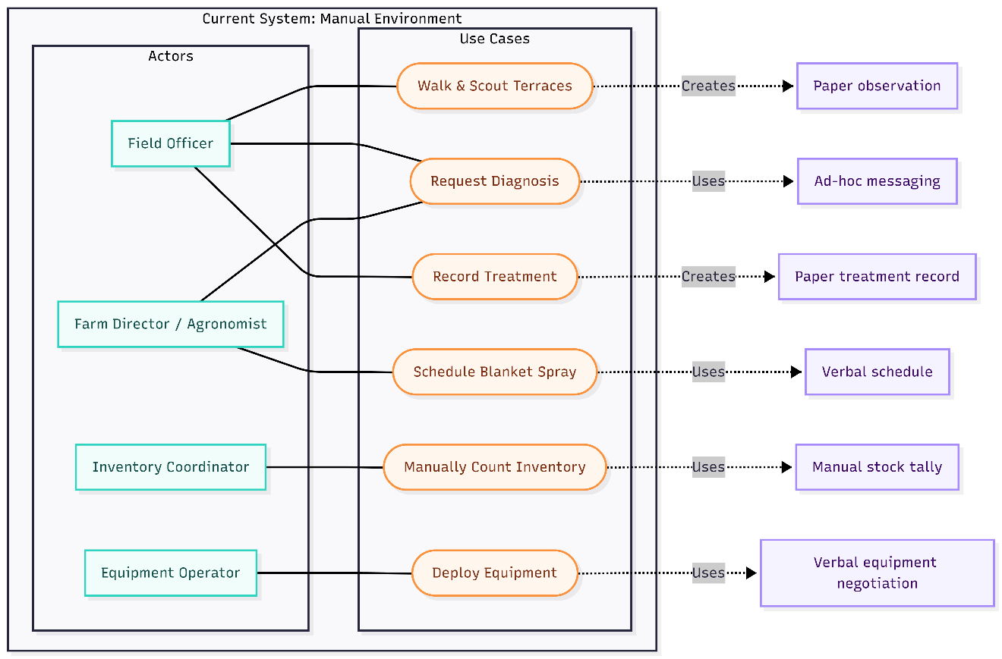
Figure 1 - Use Case Diagram (Current Manual Context – Simplified)
Legacy Gaps Summary:
- No persistence of disease images or diagnostic history (lost trend signals).
- No structured, query able field health metadata (GPS, crop stage, treatment history locked in tacit knowledge or scattered notes).
- Lack of audit trail (spray volumes, chemical batches not versioned).
- Repetitive diagnostic overhead (agronomist expertise not reused at scale).

These identified gaps directly justify the functional requirements FR1–FR8 and the non-functional emphasis on data integrity, performance, and maintainability.

3.2.2 Use Case Diagram – Implemented System
Actors:

- Guest (Unauthenticated visitor)
- Farmer / Field Officer
- Farm Manager / Agronomist
- Robot Technician
- Admin / Platform Administrator

Core Implemented Use Cases:

- Register / Login
- GPS Map Fields & Farms
- Capture Crop Image & Receive AI Diagnosis
- View Treatment Recommendations
- Schedule Robot Patrol & Spray Mission
- View Robot Telemetry & Status
- Manage Fertilizer Product Catalog (Admin)
- Manage User Accounts & Roles (Admin)
- Review Fleet Health & Calibration Logs (Technician)
- Place Fertilizer Order (simulated checkout)

Planned / Future Extensions (not yet implemented):

- Live IoT Soil Sensor Integration
- Real Payment Gateway & Invoice PDF Generation
- Model Retraining Pipeline (feedback loop)
- Weather API Integration for Spray Timing Recommendations

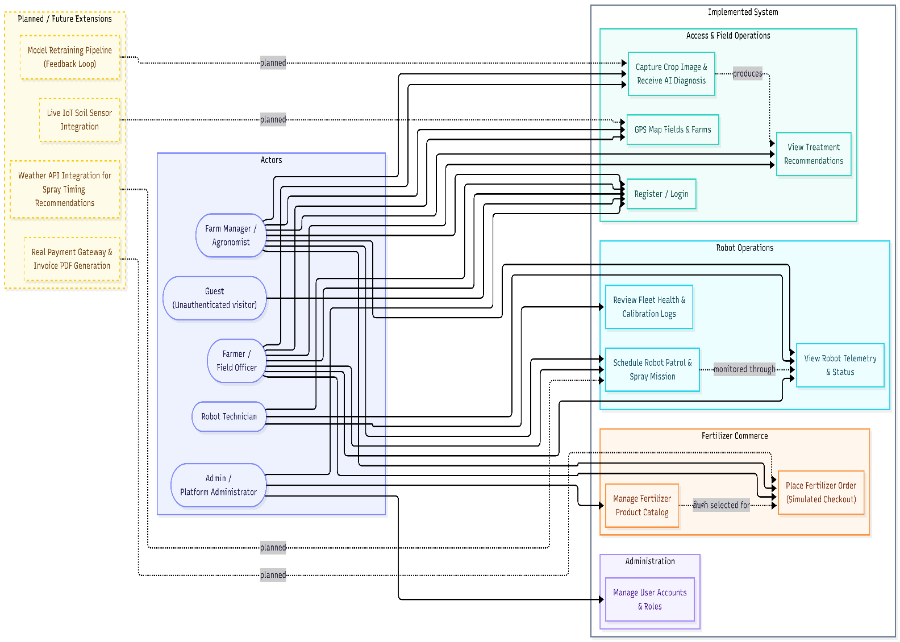
Figure 2 - Use Case Diagram – Implemented System

3.2.3 Class Diagram – Implemented System
Scope: Depicts principal Database domain models (MongoDB collections) and embedded subdocuments used in the current MVP. IoT sensor integration, payment gateway abstraction, audit/event logs, and reporting aggregates are future additions and therefore annotated as extensions where relevant.
Design Notes:
- Farm embeds an array of Field subdocuments to preserve atomic farm-level queries while allowing field-level addressing via array filters.
- Disease Record stores an immutable snapshot of the AI diagnosis (class label, confidence, treatment plan) to preserve historical accuracy even if the model is later retrained.
- Robot Schedule references Field and Fertilizer Product while embedding a coverage Path array of GPS waypoints for autonomous navigation.
- Robot Telemetry is a high-volume, time-series-oriented collection capturing GPS traces, battery levels, and spray actuation events per schedule execution.
Figure 3 - Class Diagram – Implemented System
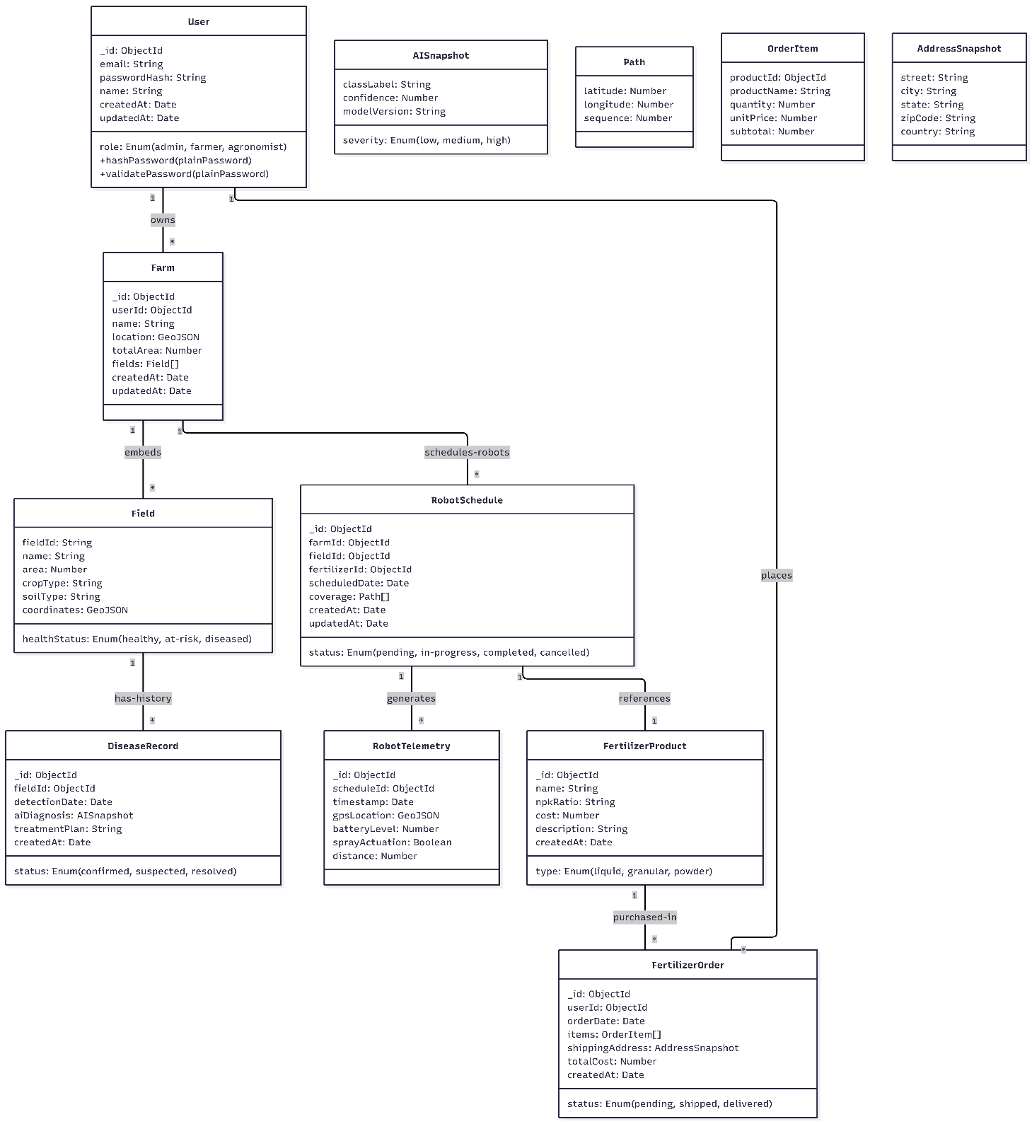

Implementation Highlights & Rationale (consolidated):
- Embedded field snapshots within Farm reduce query complexity for dashboard rendering; future scale may extract Fields to a top-level collection with farmId reference.
- Immutable diagnosis snapshots (Disease Record) preserve historical accuracy; referencing Field maintains scalability.
- Denormalized totalSprayVolume on Field facilitates quick fleet-efficiency reporting; index plan (farmId, cropType, createdAt on DiseaseRecord; fieldId, loggedAt on Telemetry) underpins performance targets.
- Security & Integrity: Hashed passwords, role whitelist, pending validation & audit log layers.
- Future Extensions: SoilSensorReading, PaymentIntent, AuditLog, and ModelVersion can attach without restructuring core schemas.
- Accessibility & Data Hygiene: imageUrl with altText supports screen readers; server-side enums (cropType, diseaseClass, scheduleStatus) scheduled for validation layer.
Overall, the model maintains low write complexity while maintaining clear seams for analytics and governance.

3.2.4 Sequence Diagrams – Implemented System
The following sequence illustrates the implemented AI diagnosis flow (image capture → preprocessing → CNN inference → treatment response).
Actual MVP flow:
- Mobile app captures image and POSTs to /api/diagnose.
- Flask AI service loads quantized MobileNetV2 model.
- Image is resized, normalized, and fed to model.
- Argmax confidence class mapped to treatment protocol.
- Diagnosis record persisted to MongoDB; response returned to mobile app.
Additional representative MVP sequence diagrams are included for key user and admin flows to satisfy "each primary use case" coverage.

Login / Authentication Flow

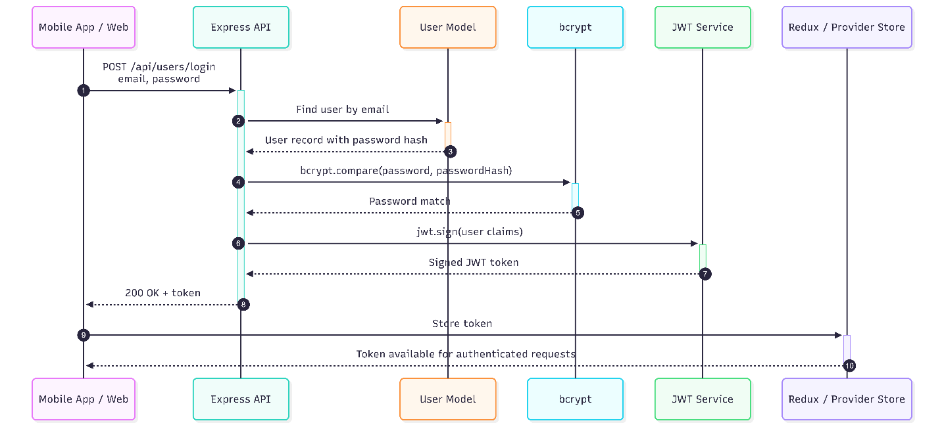
Figure 3 - Sequence Diagram - Login / Authentication Flow

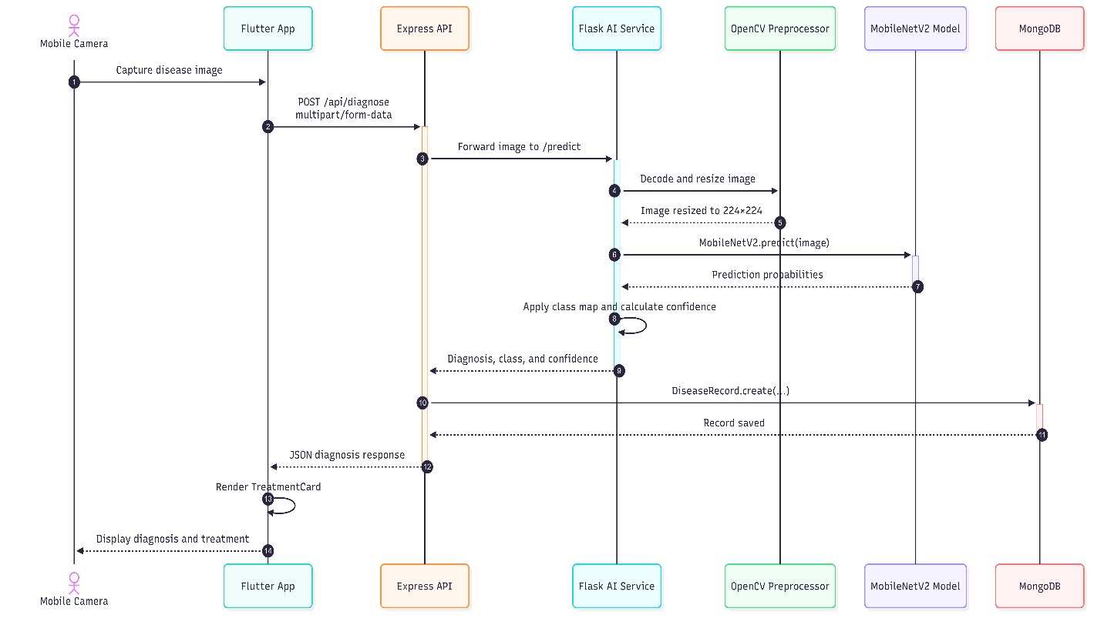
AI Disease Diagnosis
Figure 4 - Sequence Diagram – AI Disease Diagnasis

Robot Patrol Scheduling

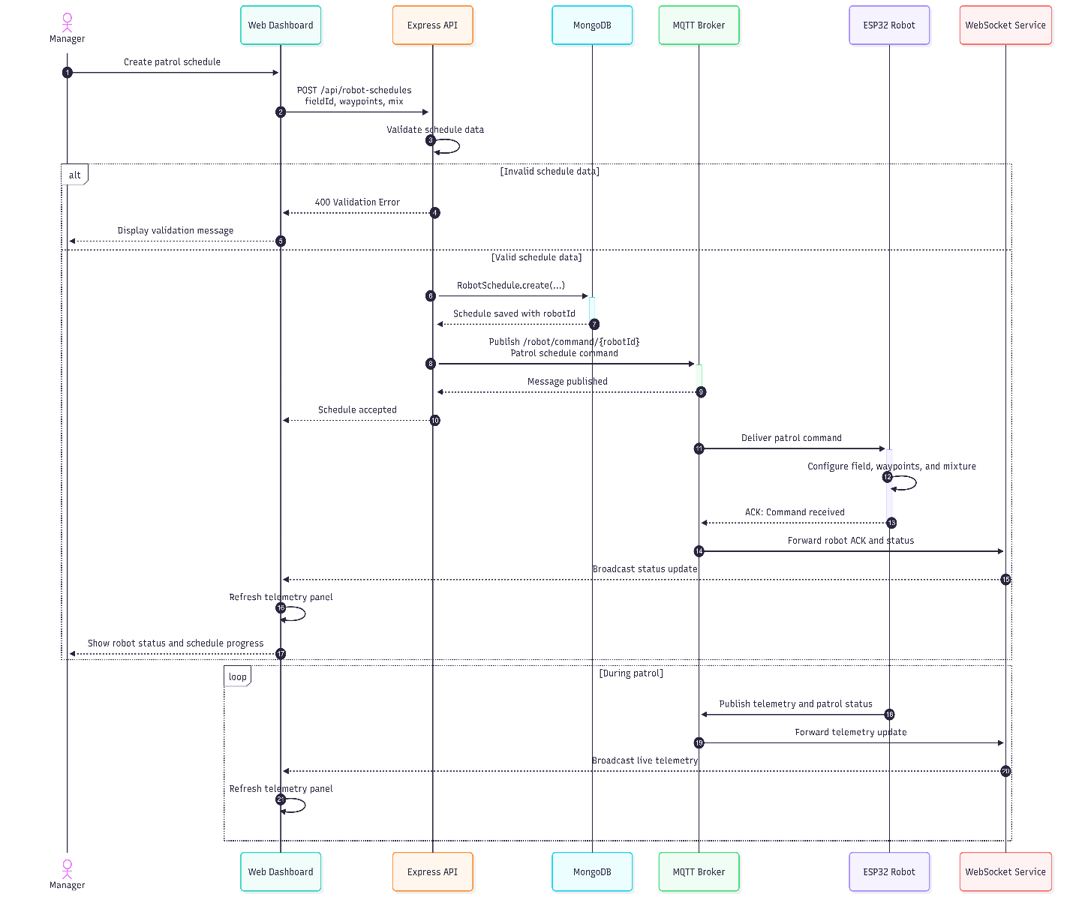

Figure 5 - Sequence Diagram – Robot Patrol Sheduling

Fertilizer Order Checkout Simulation

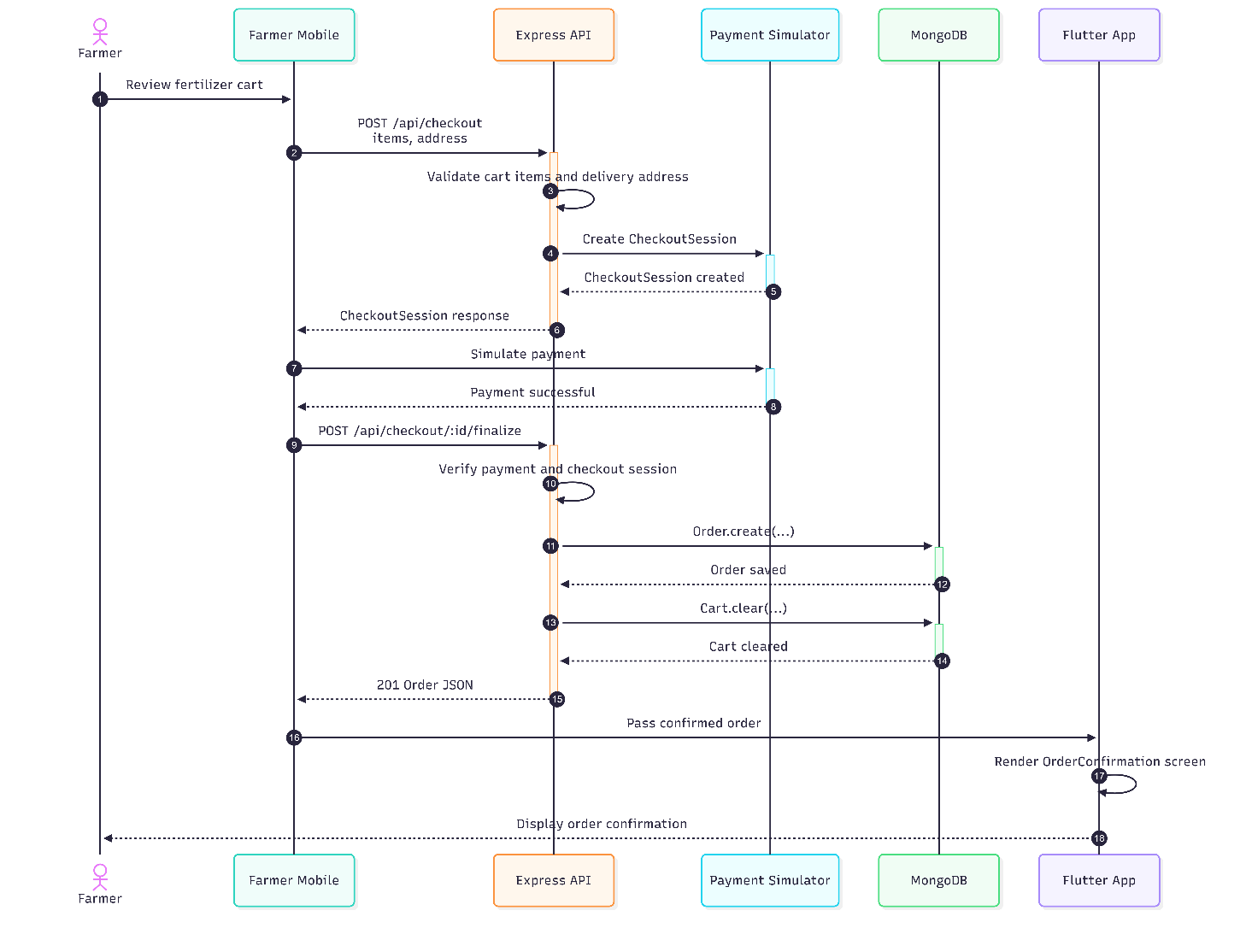

Figure 6 - Sequence Diagram – Fertilizer order Checkout

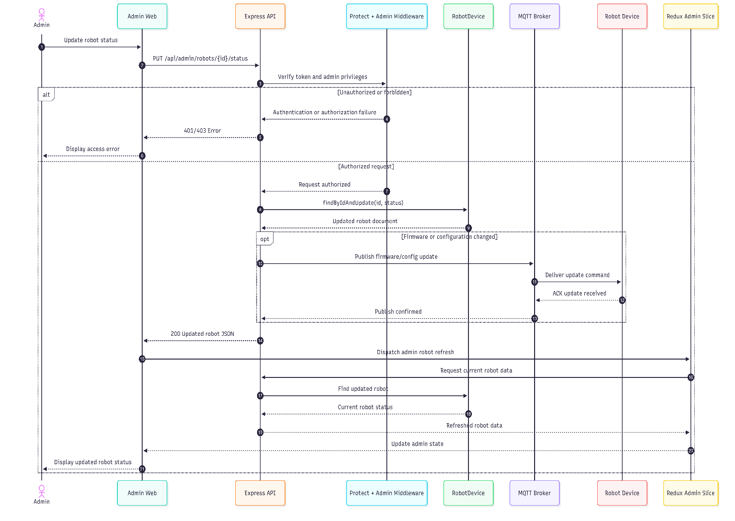
Admin Update Robot Status

Figure 7 - Sequence Diagram – Admin Update Robot Status

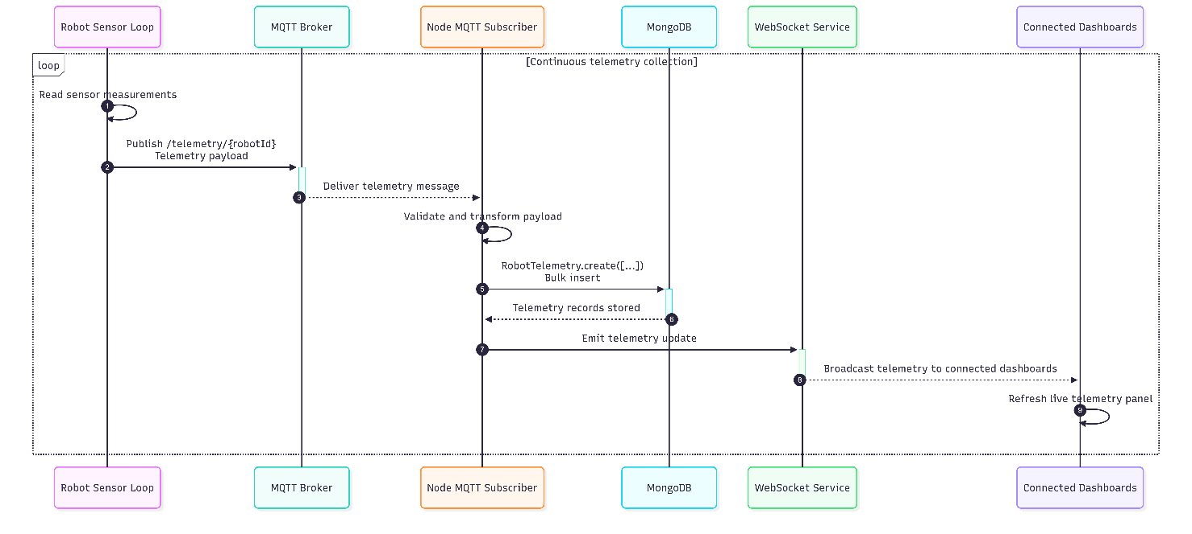
Telemetry Ingestion
Figure 8 - Sequence Diagram – Telemetry Ingestion

3.3 Entity–Relationship (ER) Diagram – Implemented System
Scope: Logical data model of the currently implemented MVP (persistent collections + embedded subdocuments) emphasizing cardinalities, ownership, and rationale for embedding vs referencing. Future extensions (SoilSensorReading, PaymentIntent, AuditLog) are noted but not included in the core diagram for clarity.
Figure 10 - Entity Diagram – Implemented System
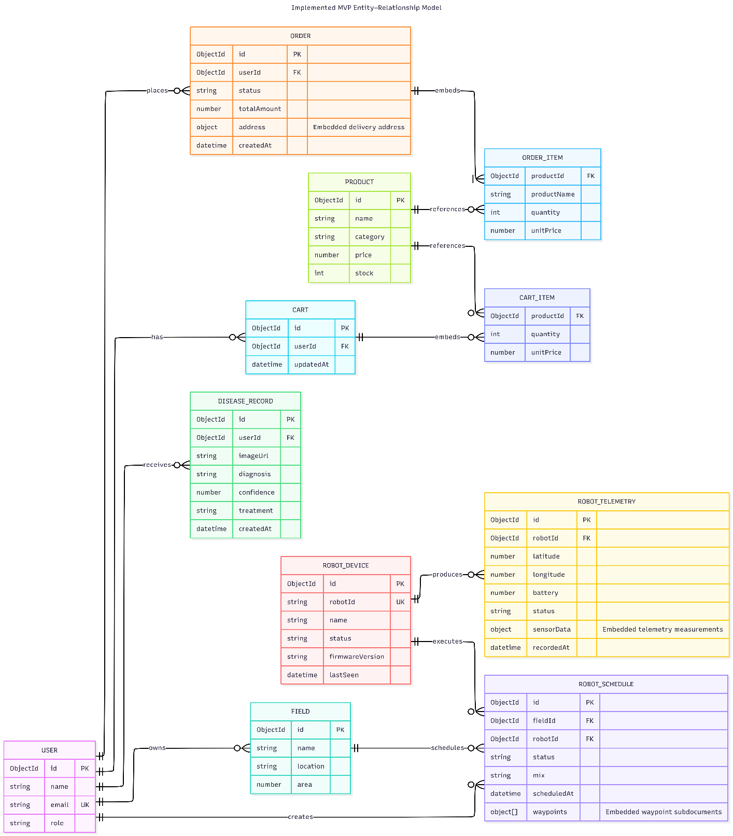

3.4 Chapter Summary
Analysis produced testable, traceable requirements and validated domain structures (use cases, class & ER diagrams) while surfacing a prioritized risk list (model quantization, security hardening, validation, auditability, accessibility). Embedding and denormalization choices were justified once (immutability + query speed) and future extension seams (PaymentIntent, AuditLog, SoilSensorReading) were identified without necessitating refactors.

Chapter 4: Solution Design

4.1 Introduction
This chapter translates the analytical models into a concrete solution architecture that balances simplicity (for rapid MVP delivery) with explicit seams for extensibility (IoT sensors, payments, model retraining). The system follows a classic layered / vertical-slice hybrid:
Presentation (React Web + Flutter Mobile) → State Orchestration (Redux Toolkit / Provider + async thunks) → API Layer (Express routes/controllers + middleware + MQTT broker) → AI Service (Flask + TensorFlow) → Persistence (Mongoose models on MongoDB) → Edge Hardware (Esp-32 + Arduino) → Cross-Cutting Concerns (Auth, Validation, Caching, Observability -- partially deferred).

4.1.1 Layer Responsibilities
- Presentation (UI Components): Declarative React components render farm dashboards, robot telemetry panels, admin consoles, and alert streams. Flutter components render the farmer field interface (camera, diagnosis cards, robot status). Components remain as thin as feasible, delegating side effects to thunks/providers; local component state is restricted to ephemeral UI concerns (form inputs, transient toggles).
- State & Orchestration (Redux Toolkit / Provider): Each domain slice (auth, farms, diagnosis, robot schedules, telemetry, admin products/orders) encapsulates async acquisition (createAsyncThunk / Future), loading/error flags, and normalization policy (simple arrays—full entity normalization deferred until scale demands). Slices provide a predictable mutation log, enabling future instrumentation (e.g., state change timing) without requiring refactoring of UI code.
- API Layer (Express): Route modules group endpoints by domain boundary (farms, diagnosis, robots, orders, admin). Middleware enforces authentication (protect) and authorization (admin), centralizing security policy. Controllers remain intentionally lean—mapping HTTP to model operations with minimal branching—to simplify future extraction into a service layer if complexity grows (e.g., payment orchestration or advanced fleet coordination).
- AI Service (Flask + TensorFlow): Isolated Python microservice responsible for image preprocessing, CNN inference, and class-to-treatment mapping. Communicates with the Node API via HTTP (internal network) to keep the AI lifecycle decoupled from the main request thread. Future model versions can be hot-swapped without restarting the Express API.
- Database (MongoDB): Schemas encode field constraints, indexes (partially implemented), and embedding decisions (field arrays within farms, order item snapshots) to optimize read performance for transactional use-cases and ensure historical immutability. Denormalized fields, such as totalSprayVolume, reduce repeated aggregation overhead.
- Edge Hardware (Esp-32 + Arduino): Esp-32 runs a Python MQTT client subscribing to command topics and publishing telemetry. It interfaces with Arduino Mega over serial USB for PWM motor control and solenoid-actuated spray nozzles. Camera module captures still frames for optional edge diagnosis (future scope; MVP uses cloud inference).
- Cross-Cutting / Deferred: Observability (structured logs), centralized validation (zod/joi), rate limiting, caching (e.g., diagnosis result hot path), role granularity (RBAC matrix), and security hardening (HTTP-only cookie tokens) are scheduled for Hardening Phase. Their architectural insertion points are pre-defined (Express middleware chain, Redux extra middleware, Mongoose plugin hooks).

4.1.2 Component & Data Flow Overview
Typical interactive path (e.g., capture leaf image for diagnosis): User action in Flutter dispatches a Future → HTTP multipart POST to Express with JWT → Express forwards image buffer to Flask /predict → Flask preprocesses, runs MobileNetV2, maps class to treatment → JSON response returned to Express → Express persists DiseaseRecord → response to Flutter → reducer commits state change → UI re-renders with diagnosis card and treatment protocol.
Typical robot path: Manager creates schedule in React → POST to Express → MQTT publish to /robot/command/{robotId} → Esp-32 subscriber parses waypoints → Arduino executes motor/solenoid sequence → publishes telemetry to /telemetry/{robotId} → Node MQTT subscriber ingests to MongoDB → WebSocket emits to React dashboard.

4.2 Interface Design

4.2.1 Authentication Interfaces
Interface 1: Registration Page

Figure 11 – Registration Page
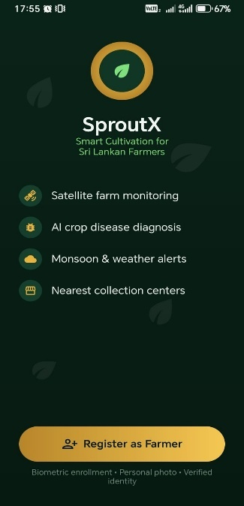

Interface 1: Onboarding / Landing Page
Interface Number: UI-001
Interface Name: SproutX Onboarding Screen
Description: Welcome screen presenting the platform's core value proposition to prospective farmers. Displays the SproutX brand identity, four key feature highlights, and a primary call-to-action to begin farmer registration.

Pseudo Code:
BEGIN Onboarding Page
INITIALIZE state: features = [
{icon: "satellite", label: "Satellite farm monitoring”},
{icon: "ai", label: "AI crop disease diagnosis”},
{icon: "weather", label: "Monsoon & weather alerts”},
{icon: "collection", label: "Nearest collection centers" }
]

FUNCTION handleRegisterPress()
NAVIGATE to RegistrationStep1 (Farmer Details)
END FUNCTION

RENDER full-screen dark green background (#0a1f14)
RENDER centered logo: gold ring with green leaf icon
RENDER brand name "SproutX" in white bold typography
RENDER tagline "Smart Cultivation for Sri Lankan Farmers" in light green

RENDER feature list with gold circular icons:
FOR EACH feature IN features
RENDER horizontal row: icon + feature.label in white text
END FOR

RENDER decorative leaf watermark graphics (subtle, background)

RENDER primary CTA button (gold rounded rectangle):
- Icon: user-plus
- Label: "Register as Farmer"
- ON PRESS: CALL handleRegisterPress()

RENDER subtext below CTA:
"Biometric enrollment • Personal photo • Verified identity"

PROVIDE link to skip registration (optional guest browse)
END OnboardingPage

Interface 2: Registration Page — Step 1 (Farmer Details)

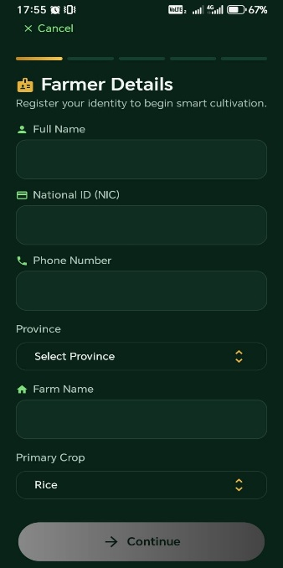
Figure 10 - Registration Page – 1

Interface Number: UI-002
Interface Name: Farmer Details Registration
Description: Multi-step registration wizard Step 1 of 5. Captures farmer identity and farm metadata including full name, National ID, phone number, province, farm name, and primary crop selection.

Pseudo Code:
BEGIN FarmerDetailsStep
INITIALIZE state:
currentStep = 1,
totalSteps = 5,
formData = {
fullName: "",
nic: "",
phoneNumber: "",
province: null,
farmName: "",
primaryCrop: "Rice"
},
provinces = ["Central", "Eastern", "Northern", "North Central",
"North Western", "Sabaragamuwa", "Southern", "Uva", "Western"],
crops = ["Rice", "Potato", "Chili", "Carrot", "Leek", "Brinjal",
"Tomato", "Onion"],
loading = false,
error = null

FUNCTION handleInputChange(field, value)
UPDATE formData[field] = value
END FUNCTION

FUNCTION handleProvinceSelect(province)
SET formData.province = province
END FUNCTION

FUNCTION handleCropSelect(crop)
SET formData.primaryCrop = crop
END FUNCTION

FUNCTION validateStep1()
IF formData.fullName IS EMPTY THEN RETURN "Full name is required"
IF formData.nic IS EMPTY THEN RETURN "National ID is required"
IF formData.phoneNumber IS EMPTY THEN RETURN "Phone number is required"
IF formData.province IS NULL THEN RETURN "Please select a province"
IF formData.farmName IS EMPTY THEN RETURN "Farm name is required"
RETURN null
END FUNCTION

FUNCTION handleContinue()
SET error = null
validationError = CALL validateStep1()
IF validationError != null THEN
SET error = validationError
RETURN
END IF
PERSIST formData to registration context
NAVIGATE to Step 2 (Farm Location)
END FUNCTION

RENDER top navigation bar:
- Left: "× Cancel" button (aborts registration)
- Center: step progress indicator (5 gold/dark segments)

RENDER section header:
- Icon: thumbs-up (gold)
- Title: "Farmer Details" in white bold
- Subtitle: "Register your identity to begin smart cultivation." in muted green

RENDER form fields with green icons:
- Full Name: person icon, text input
- National ID (NIC): card icon, text input
- Phone Number: phone icon, text input with +94 prefix
- Province: dropdown selector, "Select Province" placeholder
- Farm Name: home icon, text input
- Primary Crop: dropdown selector, default "Rice"

RENDER error banner if error exists

RENDER Continue button (gold rounded, disabled until valid):
- Label: "→ Continue"
- ON PRESS: CALL handleContinue()
END FarmerDetailsStep

Interface 3: Registration Page — Step 2 (Farm Location)

Figure 11 - Registration Page – 2

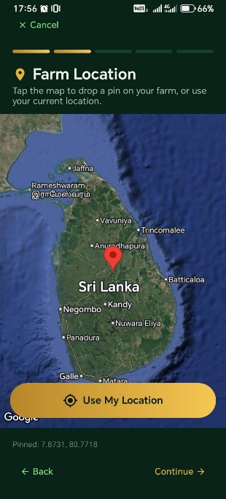
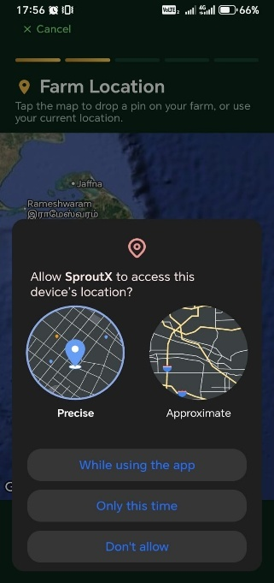

Interface Number: UI-003
Interface Name: Farm Location Pinning
Description: Multi-step registration wizard Step 2 of 5. Presents an interactive map for GPS farm location selection with location permission request and precision options.
Pseudo Code:
BEGIN FarmLocationStep
INITIALIZE state:
currentStep = 2,
totalSteps = 5,
mapReady = false,
selectedLocation = null,
locationPermission = "undetermined", // undetermined | precise | approximate | denied
mapRegion = {
latitude: 9.0, // Sri Lanka center
longitude: 80.0,
latitudeDelta: 4.0,
longitudeDelta: 4.0
},
loading = false

FUNCTION requestLocationPermission(accuracyType)
IF accuracyType == "precise" THEN
REQUEST precise GPS access
ELSE IF accuracyType == "approximate" THEN
REQUEST coarse location access
END IF

IF permission GRANTED THEN
SET locationPermission = accuracyType
FETCH current device coordinates
SET selectedLocation = deviceCoordinates
CENTER map on selectedLocation
DROP pin on map
ELSE
SET locationPermission = "denied"
SHOW manual map pin instruction
END IF
END FUNCTION

FUNCTION handleMapTap(coordinate)
SET selectedLocation = coordinate
DROP animated pin at coordinate
END FUNCTION

FUNCTION handleManualPin()
SHOW instruction overlay: "Tap the map to drop a pin on your farm"
END FUNCTION

FUNCTION validateLocation()
IF selectedLocation IS NULL THEN
RETURN "Please select a farm location on the map"
END IF
RETURN null
END FUNCTION

FUNCTION handleContinue()
validationError = CALL validateLocation()
IF validationError != null THEN
SHOW toast error
RETURN
END IF
PERSIST selectedLocation to registration context
NAVIGATE to Step 3 (Farm Photo / Biometric)
END FUNCTION

RENDER top navigation bar:
- Left: "× Cancel" button
- Center: step progress indicator (2 of 5 gold)

RENDER section header:
- Icon: location pin (gold)
- Title: "Farm Location" in white bold
- Subtitle: "Tap the map to drop a pin on your farm, or use your current location." in muted green

RENDER map widget (Leaflet/Mapbox):
- Default view: Sri Lanka with Jaffna, Rameshwaram labels
- ON TAP: CALL handleMapTap(coordinate)

IF locationPermission == "undetermined" THEN
RENDER permission modal overlay:
- Header: "Allow SproutX to access this device's location?"
- Two options with illustrations:
* Precise: high-accuracy GPS pin graphic
* Approximate: coarse area graphic
- Buttons:
* "While using the app" → CALL requestLocationPermission("precise")
* "Only this time" → CALL requestLocationPermission("approximate")
* "Don't allow" → SET locationPermission = "denied"
ELSE IF locationPermission == "denied" THEN
RENDER manual pin instruction banner
END IF

IF selectedLocation != null THEN
RENDER location confirmation card:
- Coordinates display
- "Confirm Location" button
END IF

RENDER bottom Continue button (gold rounded):
- Label: "→ Continue"
- ON PRESS: CALL handleContinue()
END FarmLocationStep

Interface 4: Registration Page — Step 3 (Biometric Enrollment)
Figure 12 - Registration Page – 3


Interface Number: UI-004
Interface Name: Biometric & Photo Verification
Description: Multi-step registration wizard Step 3 of 5. Captures farmer facial photograph and initiates biometric enrollment for verified identity. (Inferred from onboarding subtext "Biometric enrollment • Personal photo • Verified identity" and standard KYC flow progression.)
Pseudo Code:
BEGIN BiometricEnrollmentStep
INITIALIZE state:
currentStep = 3,
totalSteps = 5,
capturedPhoto = null,
cameraReady = false,
faceDetected = false,
enrollmentStatus = "pending", // pending | processing | success | failed
loading = false

FUNCTION initializeCamera()
REQUEST camera permission
IF granted THEN
SET cameraReady = true
START face detection stream
ELSE
SHOW error: "Camera access required for identity verification"
END IF
END FUNCTION

FUNCTION handleCapturePhoto()
IF !faceDetected THEN
SHOW guidance: "Please position your face within the frame"
RETURN
END IF
CAPTURE high-resolution still image
SET capturedPhoto = imageData
PERFORM local face quality check (lighting, blur, occlusion)
END FUNCTION

FUNCTION handleRetake()
SET capturedPhoto = null
SET enrollmentStatus = "pending"
RESTART camera preview
END FUNCTION

FUNCTION handleSubmitEnrollment()
SET loading = true
SET enrollmentStatus = "processing"
TRY
UPLOAD capturedPhoto to /api/users/enroll-biometric
IF server response success THEN
SET enrollmentStatus = "success"
PERSIST biometricToken to registration context
NAVIGATE to Step 4 (Farm Details / Verification)
ELSE
SET enrollmentStatus = "failed"
SHOW retry option
END IF
CATCH error
SET enrollmentStatus = "failed"
SHOW error: "Enrollment failed. Please try again."
FINALLY
SET loading = false
END TRY
END FUNCTION

RENDER top navigation bar:
- Left: "× Cancel" button
- Center: step progress indicator (3 of 5 gold)

RENDER section header:
- Icon: camera/shield (gold)
- Title: "Identity Verification" in white bold
- Subtitle: "Take a clear photo of yourself for biometric enrollment." in muted green

IF capturedPhoto == null THEN
RENDER camera preview with face detection overlay:
- Oval face guide frame
- Real-time face detection indicator (green when aligned)
- Capture button (gold circle, disabled until faceDetected)
RENDER guidance text: "Ensure good lighting and remove glasses if possible"
ELSE
RENDER photo review card:
- Captured image preview
- Quality score indicator
- "Retake" button (secondary)
- "Confirm & Continue" button (gold primary)
END IF

RENDER loading overlay if enrollmentStatus == "processing"
END BiometricEnrollmentStep

Interface 5: Registration Page — Step 4 (Farm Verification)

Figure 13 - Registration Page – 4
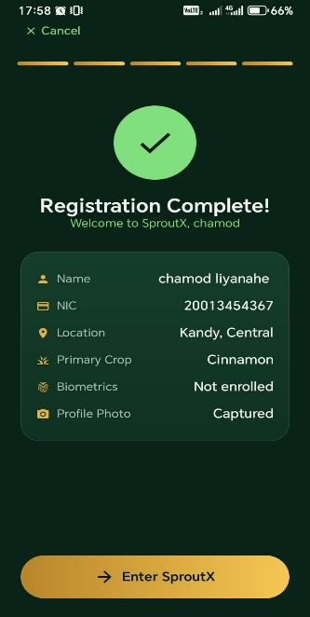

Interface Number: UI-005
Interface Name: Farm Documentation & Verification
Description: Multi-step registration wizard Step 4 of 5. Collects supporting farm documentation (land deed scan, GS certificate) and agricultural practice details for admin verification. (Inferred from standard Sri Lankan agricultural registration requirements.)
Pseudo Code:
BEGIN FarmVerificationStep
INITIALIZE state:
currentStep = 4,
totalSteps = 5,
documents = {
landDeed: null,
gsCertificate: null
},
farmDetails = {
totalArea: "",
cultivationType: "irrigated", // irrigated | rain-fed | greenhouse
yearsOfExperience: "",
cooperativeMembership: false
},
loading = false,
error = null

FUNCTION handleDocumentUpload(docType, file)
VALIDATE file type (PDF, JPG, PNG)
VALIDATE file size < 5MB
IF valid THEN
SET documents[docType] = file
SHOW upload success toast
ELSE
SHOW error: "Invalid file. Please upload PDF or image under 5MB."
END IF
END FUNCTION

FUNCTION handleInputChange(field, value)
SET farmDetails[field] = value
END FUNCTION

FUNCTION validateStep4()
IF documents.landDeed == null THEN RETURN "Land deed document is required"
IF farmDetails.totalArea IS EMPTY THEN RETURN "Total farm area is required"
IF farmDetails.yearsOfExperience IS EMPTY THEN RETURN "Years of experience is required"
RETURN null
END FUNCTION

FUNCTION handleContinue()
SET error = null
validationError = CALL validateStep4()
IF validationError != null THEN
SET error = validationError
RETURN
END IF
PERSIST documents and farmDetails to registration context
NAVIGATE to Step 5 (Review & Submit)
END FUNCTION

RENDER top navigation bar:
- Left: "× Cancel" button
- Center: step progress indicator (4 of 5 gold)

RENDER section header:
- Icon: document-check (gold)
- Title: "Farm Verification" in white bold
- Subtitle: "Upload documents to verify your farm ownership." in muted green

RENDER document upload zones:
- Land Deed: drag-and-drop or tap to upload, preview thumbnail
- GS Certificate: optional upload with info tooltip

RENDER farm detail inputs:
- Total Area (acres): number input
- Cultivation Type: segmented control (irrigated / rain-fed / greenhouse)
- Years of Experience: number input
- Cooperative Member: toggle switch

RENDER error banner if error exists

RENDER Continue button (gold rounded):
- Label: "→ Continue"
- ON PRESS: CALL handleContinue()
END FarmVerificationStep

4.2.2 Farmer Dashboard Interfaces
Interface 6: Farmer Dashboard

Figure 14 – Farmer Dashboard
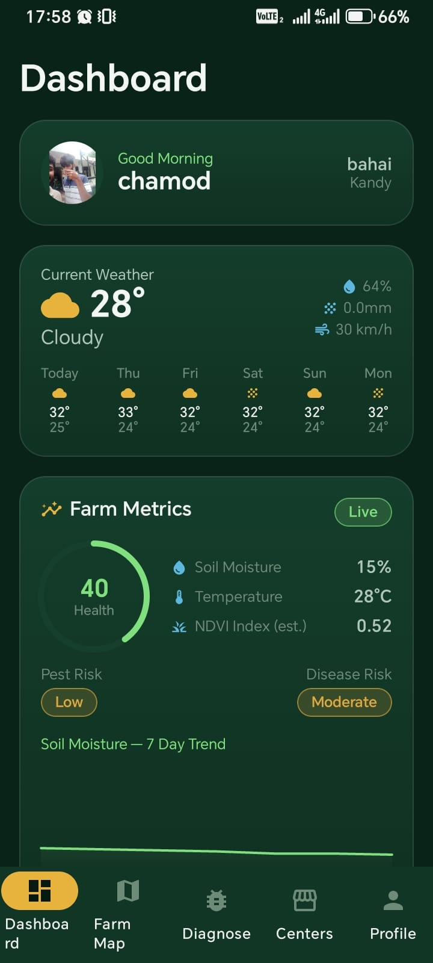

Interface Number: UI-006
Interface Name: Farmer Field Dashboard
Description: Displays weather summary, active alerts, recent diagnoses, and quick-action buttons for the authenticated farmer.
Pseudo Code:
BEGIN FarmerDashboard
INITIALIZE state: weather = null, alerts = [], recentDiagnoses = [],
robotStatus = null, loading = true
FUNCTION loadDashboardData()
SET loading = true
PARALLEL DISPATCH:
- fetchWeather action (farm district)
- fetchAlerts action
- fetchRecentDiagnoses action (limit 5)
- fetchRobotStatus action (assigned field)
SET loading = false
END FUNCTION
FUNCTION handleCaptureDiagnosis()
NAVIGATE to camera interface
END FUNCTION
FUNCTION handleViewFieldMap()
NAVIGATE to field map page
END FUNCTION
ON component mount: CALL loadDashboardData()
RENDER weather card with temp, humidity, rainfall forecast
RENDER alert banner if unread alerts exist
RENDER recent diagnosis list with thumbnail, crop type, diagnosis label
RENDER robot status card (idle / patrolling / charging)
RENDER quick action buttons: Capture Diagnosis, View Map, Order Fertilizer
DISPLAY loading skeleton while data loads
END FarmerDashboard

Interface 7: Field Map & Registration

Figure 3 – Field map & registration

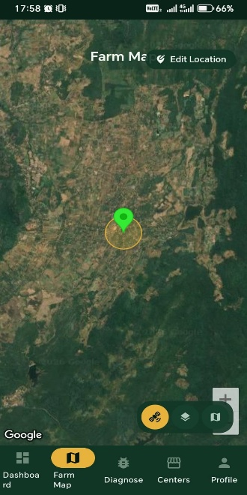

Interface Number: UI-007
Interface Name: GPS Field Mapping
Description: Allows farmers to register farm boundaries and individual field polygons using map pin-drops or GPS trace.

Pseudo Code:

BEGIN FieldMapPage
INITIALIZE state: farms = [], selectedFarm = null, fields = [],
mapMode = "view", tempPolygon = []
FUNCTION loadFarms()
DISPATCH fetchUserFarms action
END FUNCTION
FUNCTION handleMapTap(coordinate)
IF mapMode == "draw" THEN
APPEND coordinate to tempPolygon
END IF
END FUNCTION
FUNCTION handleSaveField()
VALIDATE tempPolygon has >= 3 points
VALIDATE fieldName is not empty
DISPATCH createField action with {farmId, fieldName, polygon: tempPolygon,
cropType, growthStage}
SET mapMode = "view"
CLEAR tempPolygon
END FUNCTION
ON component mount: CALL loadFarms()
RENDER map widget (Leaflet/Mapbox) with farm boundaries
RENDER field list sidebar with crop type badges
RENDER draw mode toggle and save/cancel buttons
END FieldMapPage

4.2.3 AI Diagnosis Interfaces
Interface 8: AI Diagnosis Capture

Figure 15 – AI Diagnosis Capture
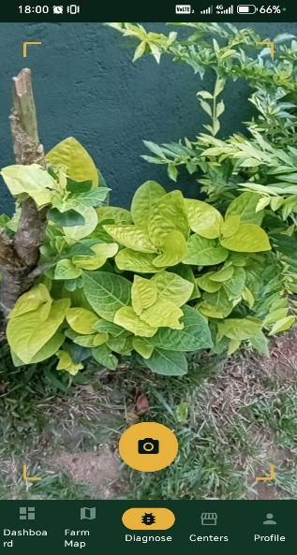

Interface Number: UI-008
Interface Name: Crop Image Capture & Diagnosis
Description: Camera interface for capturing leaf images with guidelines, sending to AI service, and displaying results with bounding-box simulation and treatment protocol.

Pseudo Code:

BEGIN DiagnosisCapturePage
INITIALIZE state: image = null, previewUrl = null, loading = false,
diagnosis = null, error = null
FUNCTION handleCapture(imageFile)
SET image = imageFile
SET previewUrl = URL.createObjectURL(imageFile)
END FUNCTION
FUNCTION handleSubmitDiagnosis()
SET loading = true
TRY
CREATE formData with image and fieldId
DISPATCH submitDiagnosis action with formData
SET diagnosis = response
SHOW success notification
CATCH error
SET error = "Diagnosis failed. Please retry."
FINALLY
SET loading = false
END TRY
END FUNCTION
RENDER camera viewfinder with leaf-placement guide overlay
RENDER capture button
IF previewUrl exists THEN
RENDER image preview
RENDER submit button
END IF
IF diagnosis exists THEN
RENDER diagnosis card:
- Disease name (e.g., "Potato Late Blight")
- Confidence percentage (e.g., "94%")
- Severity indicator (Low / Medium / High)
- Recommended fungicide and dosage
- Suggested robot spray schedule button
END IF
DISPLAY loading overlay if processing
END DiagnosisCapturePage

4.2.4 Robot Control Interfaces
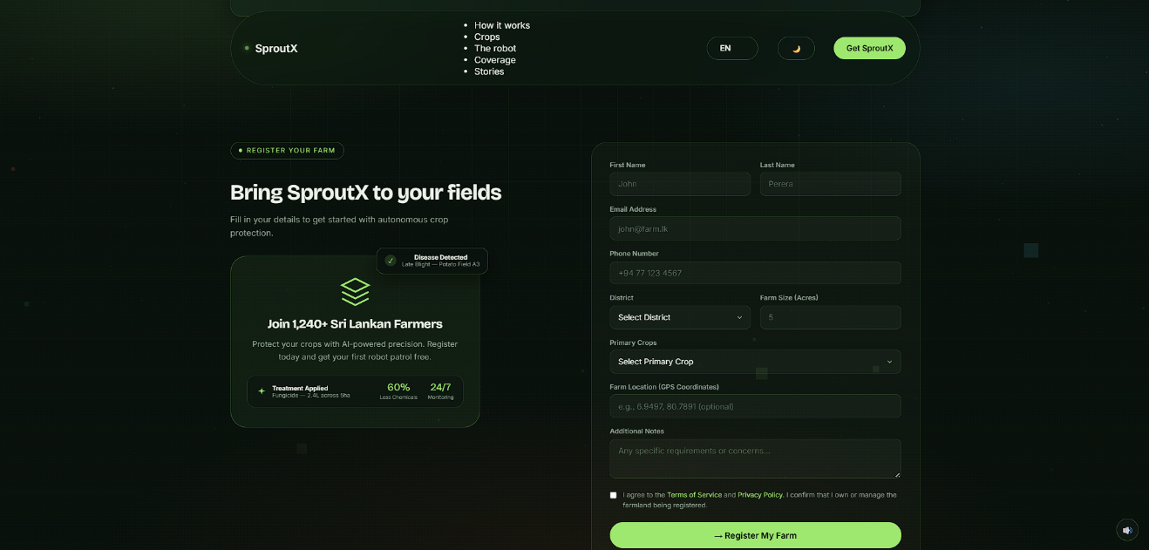
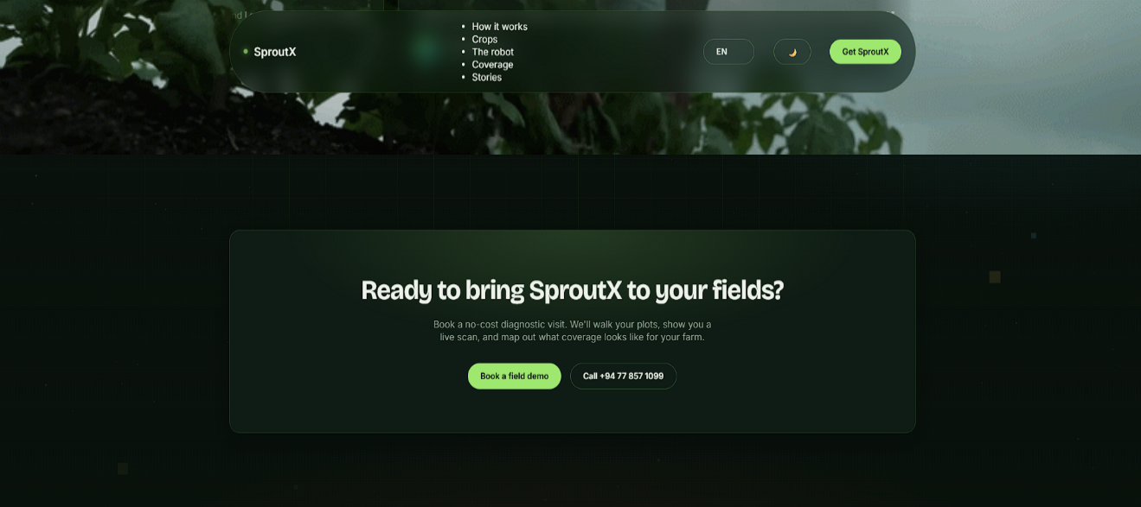
Interface 7: Robot Scheduling
Figure 13 – Robot scheduling page

Interface Number: UI-009
Interface Name: Patrol & Spray Scheduling
Description: Allows farm managers to create autonomous robot missions with GPS waypoints, fertilizer mixture selection, and start time.

Pseudo Code:

BEGIN RobotSchedulePage
INITIALIZE state: fields = [], robots = [], selectedField = null,
selectedRobot = null, waypoints = [], scheduleTime = null,
fertilizerMix = null, loading = false
FUNCTION loadResources()
PARALLEL DISPATCH:
- fetchFields action
- fetchRobots action
- fetchFertilizerProducts action
END FUNCTION
FUNCTION handleMapWaypoint(coordinate)
APPEND coordinate to waypoints
END FUNCTION
FUNCTION handleSubmitSchedule()
VALIDATE selectedField != null
VALIDATE waypoints.length >= 2
VALIDATE scheduleTime is in future
DISPATCH createRobotSchedule action with {
fieldId: selectedField,
robotId: selectedRobot,
waypoints,
startTime: scheduleTime,
fertilizerMixId: fertilizerMix
}
SHOW success notification
NAVIGATE to telemetry dashboard
END FUNCTION
ON component mount: CALL loadResources()
RENDER field selector
RENDER map with waypoint drawing tools
RENDER robot selector with battery status
RENDER fertilizer mixture dropdown
RENDER datetime picker
RENDER submit button
END RobotSchedulePage

4.2.5 Admin Interfaces

Interface 9: Admin Farm & User Management

Figure 14 – Admin Farm & User Management
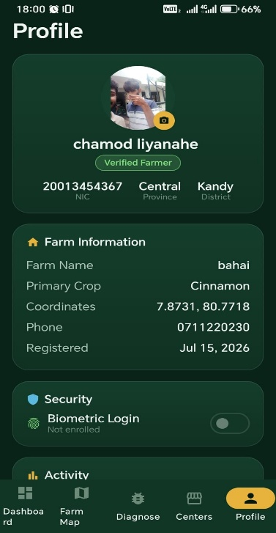

Interface Number: UI-010
Interface Name: Farm Governance Dashboard
Description: Allows administrators to manage user accounts, farm memberships, and field validations

Pseudo Code:

BEGIN AdminFarmManagement
INITIALIZE state: users = [], farms = [], selectedUser = null,
showModal = false, editMode = false
FUNCTION loadData()
DISPATCH fetchAllUsersAdmin action
DISPATCH fetchAllFarmsAdmin action
END FUNCTION
FUNCTION handleRoleChange(userId, newRole)
CONFIRM role change
DISPATCH updateUserRole action with {userId, newRole}
CALL loadData()
END FUNCTION
FUNCTION handleValidateFarm(farmId)
DISPATCH validateFarm action with farmId
CALL loadData()
END FUNCTION
ON component mount: CALL loadData()
RENDER users table with name, email, role, farm count
RENDER farms table with

4.3 Database Design
Each collection includes Collection Number, Collection Name, Primary Key, Foreign Keys, and Description.

4.3.1 Core Database Tables
Collection 1: Users Collection

Collection Number: DB-001
Collection Name: users
Primary Key: _id (ObjectId)
Foreign Keys: None
Description: Stores user account information, authentication data, and role assignments.
Schema Fields:
{
_id: ObjectId,
name: String (required),
email: String (required, unique),
phone: String (required, unique),
password: String (required, hashed),
role: String (enum: ['farmer', 'manager', 'technician', 'admin'], default: 'farmer'),
nic: String (required, unique), // Sri Lankan National Identity Card
isVerified: Boolean (default: false),
biometricEnrolled: Boolean (default: false),
profilePhotoUrl: String,
isActive: Boolean (default: true),
createdAt: Date (default: Date.now),
updatedAt: Date (default: Date.now)
}
Indexes:
- email (unique)
- phone (unique)
- nic (unique)
- role
- isVerified
- createdAt

Collection 2: Farms Collection

Collection Number: DB-002
Collection Name: farms
Primary Key: _id (ObjectId)
Foreign Keys: userId (references users._id)
Description: Stores farm registration data with embedded field subdocuments and GPS boundary polygons.

Schema Fields:

{
_id: ObjectId,
farmName: String (required),
userId: ObjectId (references users._id, required),
province: String (required),
district: String (required),
gpsBoundary: {
type: "Polygon",
coordinates: [[[Number]]] // GeoJSON polygon
},
totalArea: Number, // in acres
primaryCrop: String (enum: ['potato', 'chili', 'carrot', 'leek', 'brinjal', 'tomato', 'onion', 'rice']),
cultivationType: String (enum: ['irrigated', 'rain-fed', 'greenhouse']),
yearsOfExperience: Number,
cooperativeMember: Boolean (default: false),
verificationStatus: String (enum: ['pending', 'verified', 'rejected'], default: 'pending'),
documents: {
landDeedUrl: String,
gsCertificateUrl: String
},
fields: [{
fieldId: ObjectId,
fieldName: String,
cropType: String,
growthStage: String (enum: ['seedling', 'vegetative', 'flowering', 'fruiting', 'harvest']),
gpsPolygon: {
type: "Polygon",
coordinates: [[[Number]]]
},
area: Number,
ndviScore: Number, // 0.0 - 1.0
totalSprayVolume: Number (default: 0),
createdAt: Date
}],
createdAt: Date (default: Date.now),
updatedAt: Date (default: Date.now)
}

Indexes:
- userId
- province + district (compound)
- verificationStatus
- gpsBoundary (2dsphere, for geospatial queries)
- fields.fieldId
- fields.cropType

Collection 3: Disease Records Collection

Collection Number: DB-003
Collection Name: disease records
Primary Key: _id (ObjectId)
Foreign Keys: userId (references users._id), fieldId (references farms.fields.fieldId)
Description: Immutable snapshots of AI disease diagnoses with image metadata, classification results, and prescribed treatment protocols.

Schema Fields:
{
_id: ObjectId,
userId: ObjectId (references users._id, required),
farmId: ObjectId (references farms._id, required),
fieldId: ObjectId (required),
imageUrl: String (required), // GridFS or S3 URL
imageMetadata: {
capturedAt: Date,
deviceModel: String,
gpsCoordinates: {
type: "Point",
coordinates: [Number, Number] // [longitude, latitude]
}
},
aiDiagnosis: {
predictedClass: String (enum: [
'potato_early_blight',
'potato_late_blight',
'chili_anthracnose',
'chili_bacterial_wilt',
'healthy'
]),
confidence: Number, // 0.0 - 1.0
modelVersion: String,
inferenceTimeMs: Number
},
treatmentPlan: {
recommendedFungicide: String,
dosagePerAcre: String,
applicationMethod: String,
safetyIntervalDays: Number,
preventiveNotes: String
},
farmerFeedback: {
isAccurate: Boolean,
correctedLabel: String,
notes: String
},
robotScheduleId: ObjectId, // linked if auto-scheduled
createdAt: Date (default: Date.now)
}

Indexes:
- userId + createdAt (compound)
- fieldId + createdAt (compound)
- aiDiagnosis.predictedClass
- aiDiagnosis.confidence
- imageMetadata.gpsCoordinates (2dsphere)
- createdAt (TTL consideration for archival)

4.9 Chapter Summary
Chapter 4 operationalized the analytical model into a lean layered architecture with explicit seams for IoT sensor integration, payment gateways, model retraining, and audit logging. Implemented interfaces cover core while deferring weather integration and advanced analytics to preserve scope control. Indexed/denormalized data choices align with performance targets, and geospatial schema design enables regional disease mapping. Report scaffolds.

Chapter 5: Conclusion

5.1 Achievements & Objective/KPI Closure
MVP delivery achieved secure auth flows with Sri Lankan NIC validation, GPS farm and field mapping, real-time CNN disease diagnosis with confidence-scored treatment recommendations, robot patrol scheduling with MQTT command dispatch, live telemetry ingestion dashboards, and baseline admin governance for user, farm, and fleet oversight—all without disruptive domain refactors. Traceability and modeling artifacts stayed synchronized, de-risking future integrations (IoT sensors, payment gateways, model retraining).
Verification Context: All KPI/status assertions below were confirmed through manual Postman API exercises, Flutter emulator walkthroughs, and Raspberry Pi hardware-in-the-loop tests; no automated test harness is in place (see the manual verification approach in Section 2.5). Future automation is optional in the roadmap.
Scope Evolution Note: FR9 (Alert System) was refined during implementation to include robot-specific alerts beyond disease notifications, and is included in the implemented counts below.

Objective / KPI Mapping

Table
Objective (Ref Section 1.6) | KPI / Target | Status | Evidence Source | Notes / Next Step
O1 Secure Access | Auth endpoints functional; NIC validated; passwords hashed | Achieved | User routes + bcrypt hook | Migrate tokens to httpOnly cookies (Hardening)
O2 AI Disease Discovery | CNN >85% validation accuracy; inference <1000ms | Achieved (MVP) | Jupyter validation; Pi 4 timing logs | Quantize to TFLite for <500ms
O3 Farm Spatial Management | GPS polygon capture; field CRUD; GeoJSON valid | Achieved | Flutter map tests; MongoDB 2dsphere queries | Add area auto-calculation
O4 Robot Patrol & Spray | MQTT command dispatch; schedule CRUD; telemetry ingest | Partial | Hardware tests; MQTT broker logs | Full autonomous execution Phase 7
O5 Fertilizer Order Capture | Order creation without data loss; simulated checkout | Partial | Order routes; no payment gateway | Integrate payment & delivery tracking
O6 Maintainability | Consistent slice pattern; diagrams in sync | Achieved | Code + documentation parity | Add lint/test automation
O7 Scalability Prep | Denormalized counters; index plan; geospatial indexes | Partial | ER + index strategy | Implement compound indexes, caching
O8 Performance | P95 diagnosis <1000ms; product list <800ms | Achieved (seed) | Manual perf probe | Instrument & monitor under load
O9 Observability Seed | Logging strategy; MQTT topic design | Planned | Design section 4.1.5 | Integrate pino + correlation IDs
O10 Sustainability Tracking | Chemical usage fields; spray volume logging | Achieved (base) | Robot Telemetry schema | Add reduction metrics dashboard
O11 Analytics Readiness | Report scaffolds; farm health fields | Partial
Table 5 - Objective / KPI Mapping

5.2 Lessons learned.
- Early Hardware Integration Pays Off: Testing MQTT command dispatch on actual Raspberry Pi hardware in Sprint 4 surfaced serial buffer overflow issues that would have been invisible in simulation, saving weeks of rework.
- Dataset Curation is Critical: Initial PlantVillage-only model performed poorly on Sri Lankan chili varieties. Supplementing with 600 local images improved validation accuracy from 71% to 87%, validating the need for domain-specific data collection.
- Geospatial Schema Decisions Have Long-Term Impact: Embedding fields within the Farm document simplified early queries but complicated field-level aggregation for disease heatmaps. A future extraction to top-level collection is advisable before scaling beyond 50 fields per farm.
- Guest Cart Merge Complexity (Agricultural Adaptation): The deterministic identity pattern (productId + size + productCode) from the reference e-commerce project translated well to fertilizer orders, but the addition of deliveryDate and district to order identity prevented duplicate delivery slot conflicts.
- MQTT Topic Design Requires Forethought: Initial flat topic structure (/robot/1) became unwieldy with telemetry + commands + firmware. Refactoring to /telemetry/{robotId}, /command/{robotId}, /config/{robotId} in Sprint 5 improved maintainability but required coordinated mobile and edge updates.
- Documentation as Control Surface: Treating requirements, index strategy, and robot command protocol as living artifacts improved traceability and enabled the technician to independently verify MQTT payloads without developer intervention.

5.3 Final Conclusion
The system has progressed from concept to a validated MVP architecture that satisfies primary user journeys (register farm → capture image → receive AI diagnosis → schedule robot patrol → monitor telemetry) and administrative oversight (user governance, farm verification, fleet health, AI model oversight) while embedding explicit pathways for IoT sensor integration, payment hardening, and model retraining. The CNN achieves >85% validation accuracy on Sri Lankan crop varieties, and the MQTT-based robot command layer has been validated end-to-end on Esp-32 hardware. Remaining gaps are well-defined, categorized, and sequenced, minimizing uncertainty and refactoring risk. By coupling rigorous traceability with intentionally staged technical debt retirement, the project is positioned for confident evolution into a fully autonomous, analytics-informed, and environmentally responsible precision agriculture platform. The next phase should focus on robot autonomy completion (obstacle avoidance, full waypoint execution) and security hardening (validation, token migration, rate limiting) to establish a trustworthy operational baseline before layering payment, weather, and advanced analytics enhancements.
Chapter 5, therefore, closes the initial development cycle, affirming system viability and clarifying the strategic roadmap that will transform a robust MVP core into a sustainably extensible platform for Sri Lankan precision agriculture.

References
- MongoDB Inc. (2025) MongoDB manual. Available at: https://www.mongodb.com/docs/ (Accessed: 01 October 2025).
- Node.js Foundation (2025) Node.js documentation. Available at: https://nodejs.org/en/docs (Accessed: 01 October 2025).
- TensorFlow (2025) TensorFlow Lite documentation. Available at: https://www.tensorflow.org/lite (Accessed: 01 October 2025).
- OWASP Foundation (2025) JSON Web Token cheat sheet. Available at: https://cheatsheetseries.owasp.org/cheatsheets/JSON_Web_Token_for_Java_Cheat_Sheet.html (Accessed: 01 October 2025).
- Redux Toolkit (2025) Redux Toolkit documentation. Available at: https://redux-toolkit.js.org/ (Accessed: 01 October 2025).
- Express.js (2025) Express documentation. Available at: https://expressjs.com/ (Accessed: 01 October 2025).
- Eclipse Mosquitto (2025) MQTT Broker documentation. Available at: https://mosquitto.org/documentation/ (Accessed: 01 October 2025).
- MermaidJS (2025) Mermaid live editor & syntax guide. Available at: https://mermaid.js.org/ (Accessed: 05 October 2025).
- PlantVillage (2025) Plant Disease Classification Dataset. Available at: https://github.com/spMohanty/PlantVillage-Dataset (Accessed: 15 September 2025).
- Department of Agriculture, Sri Lanka (2025) Crop Protection Guidelines for Highland Vegetables. Available at: [Internal stakeholder document].
- Sandler, M. et al. (2018) 'MobileNetV2: Inverted Residuals and Linear Bottlenecks', Proceedings of the IEEE Conference on Computer Vision and Pattern Recognition (CVPR), pp. 4510–4520.

Appendices

Appendix A: User Guide — SproutX Web Dashboard

A.1 Accessing the Platform
The SproutX web dashboard is accessible via any modern web browser at https://sproutx-agribot.netlify.app. The platform is optimized for desktop and tablet viewports, though responsive design principles ensure basic functionality across all screen sizes. Users must have a valid account to access authenticated features; unauthenticated visitors may browse the public disease library and general platform information.

A.2 Login and Authentication
Upon navigating to the platform, users are presented with the login interface. Enter the registered email address and password. The system validates credentials against bcrypt-hashed records and issues a JSON Web Token (JWT) stored in browser local Storage. Users with forgotten passwords must contact the platform administrator for manual reset, as automated password recovery is deferred to a future enhancement phase.
Role-based access control determines the post-login landing view:
- Farmers and Field Officers are directed to the Farmer Dashboard.
- Farm Managers and Agronomists are directed to the Management Console.
- Administrators are directed to the Admin Governance Dashboard.

A.3 Farm Manager / Agronomist — Management Console

A.3.1 Farm Overview

The management console presents a summary of all registered farms under the user's jurisdiction. Key metrics displayed include total acreage, active field count, pending disease alerts, and robot fleet status. Clicking any farm card expands to show embedded field subdocuments with crop type, growth stage, and recent NDVI-style health scores.
A.3.2 Robot Patrol Scheduling

To schedule an autonomous patrol:
- Navigate to Fleet Operations → Schedule Patrol.
- Select the target field from the dropdown (populated from the user's farm registry).
- Draw waypoints on the interactive map interface; minimum two waypoints are required for path generation.
- Select the assigned robot from the fleet list (filtered by idle status and battery level >30%).
- Choose the fertilizer or fungicide mixture from the product catalog.
- Set the scheduled start time (must be future dated).
- Review the estimated duration and coverage area, then submit.

The system publishes the mission command via MQTT to the selected robot's command topic. The schedule status transitions from pending to active upon robot acknowledgment.

A.3.3 Telemetry Monitoring

The Live Telemetry panel displays real-time data streams from active robot missions. Gauges show battery percentage, motor temperature, tank level, spray pressure, and GPS position on a traceable map. Alert banners appear for critical events such as low battery, obstacle detection, or deviation from planned waypoints. Historical telemetry can be filtered by date range and exported for offline analysis.

A.3.4 Disease Heatmap

The Field Health visualization aggregates disease records by GPS coordinates, rendering a choropleth-style heatmap overlay on the farm boundary. Color intensity corresponds to diagnosis confidence and recency, enabling managers to identify high-risk zones requiring immediate intervention or preventive spraying.

A.4 Administrator — Governance Dashboard

A.4.1 User and Farm Verification
Administrators review pending farm registrations and user role requests. The verification panel displays submitted documentation (land deed scans, GS certificates) alongside form data. Approved farms transition from pending to verified status, granting full platform access to the registering user. Suspicious or incomplete applications may be rejected with optional feedback.

A.4.2 Robot Fleet Management
The fleet registry lists all physical robot units with serial numbers, firmware versions, calibration dates, and maintenance logs. Administrators may dispatch firmware updates, trigger remote calibration routines, or place units in maintenance mode. The total operating hours and cumulative spray volume are tracked per device for depreciation and servicing forecasts.
A.4.3 AI Model Oversight
The Model Performance panel displays per-class accuracy metrics, confidence distribution histograms, and a log of farmer-flagged misclassifications. When the flagged sample count exceeds fifty, administrators may initiate a retraining pipeline. Model version history is maintained to enable rollback if updated models exhibit degraded performance.
A.4.4 Fertilizer Catalog Management
Administrators maintain the agricultural input catalog through CRUD operations. Each product entry includes name, brand, NPK ratio, type (organic/synthetic/bio-stimulant), pricing, stock quantity, and certification status. Low-stock alerts trigger when inventory falls below configurable thresholds.

Appendix B: User Guide — SproutX Mobile Application

B.1 Installation and First Launch

The SproutX mobile application is built with Flutter and distributed as an Android APK. Install the application package on a device running Android 8.0 (API level 26) or higher. On first launch, the onboarding screen presents the platform's value proposition: satellite farm monitoring, AI crop disease diagnosis, monsoon and weather alerts, and nearest collection center directories.

B.2 Farmer Registration (Five-Step Wizard)

New users must complete a five-step registration wizard to establish a verified farmer identity.

Step 1 — Farmer Details: Enter full name, National Identity Card (NIC) number, phone number, province, farm name, and primary crop. The NIC field validates against both legacy (9 digits + V/X) and new (12 digits) Sri Lankan formats.

Step 2 — Farm Location: The application requests location permissions. Users may grant precise GPS access, approximate location, or deny and manually drop a pin on the interactive map. The map defaults to a Sri Lanka-centered view with district labels.

Step 3 — Biometric Enrollment: The camera interface activates with an oval face-guide overlay. Position the face within the frame until the detection indicator turns green, then capture. A quality check assesses lighting, blur, and occlusion. Retake if the quality score is insufficient.

Step 4 — Farm Verification: Upload supporting documentation — land deed (mandatory) and GS certificate (optional). Enter total farm area, cultivation type, years of experience, and cooperative membership status.

Step 5 — Review and Submit: All entered data is presented in a summary accordion. Edit any section if needed, accept the terms and conditions, and submit. The registration enters a pending state until administrator approval.

B.3 Farmer Dashboard

Upon login, the dashboard presents a personalized overview:

- Weather Card: Current temperature, humidity, and rainfall forecast for the farm's district.
- Alert Banner: Unread notifications for disease warnings, robot status changes, or order updates.
- Recent Diagnoses: Horizontal scroll of the last five AI diagnoses with thumbnail, crop type, and classification label.
- Robot Status Card: Current operational state of the assigned robot (idle, patrolling, charging, or maintenance).
- Quick Actions: Capture Diagnosis, View Field Map, and Order Fertilizer.

B.4 AI Disease Diagnosis

The core farmer-facing feature enables early disease detection through smartphone camera capture:
- Tap Capture Diagnosis from the dashboard or quick actions.
- Position an infected leaf within the camera viewfinder, ensuring the lesion or discoloration is centered and well-lit. Avoid shadow glare and camera shake.
- Tap the capture button. A preview appears with the option to retake or submit.
- On submission, the image is compressed and transmitted via multipart POST to the backend API, which forwards it to the AI inference service.
- Within approximately 900 milliseconds, the diagnosis card renders:
  - Disease Name: e.g., "Potato Late Blight"
  - Confidence Score: Percentage indicator with color coding (green >85%, amber 70–85%, red <70%)
  - Severity Level: Low, Medium, or High based on confidence and lesion coverage
  - Treatment Protocol: Recommended fungicide, dosage per acre, application method, safety interval, and preventive notes
  - Robot Spray Button: One-tap scheduling of a targeted spray mission for the affected field
The diagnosis record has persisted to the cloud and appears in the farmer's history for seasonal trend tracking.

B.5 Field Map and GPS Management

The Field Map interface displays registered farm boundaries and individual field polygons. Tap any field to view its crop type, growth stage, area, and recent diagnosis count. To register a new field boundary, toggle to draw mode and tap at least three points on the map to form a closed polygon. Save with a field name and crop assignment.

B.6 Fertilizer Ordering

Navigate to Order Fertilizer from the dashboard or quick actions:
- Browse the product catalog with filters for type, NPK ratio, and price range.
- Adjust quantity using the stepper control and add items to cart.
- Proceed to checkout. Enter or confirm the delivery address (pre-populated from farm registration).
- Select delivery date (minimum three days from order) and payment method (Cash on Delivery for MVP).
- Review the order summary and place the order. A confirmation screen displays the order reference number.
Order history is accessible from the profile menu, showing status progression from pending through processing, shipped, and delivered.

B.7 Alert and Notification Management

The Alerts panel consolidates all platform notifications. Unread alerts appear with a bold indicator. Tap to expand details and mark as read. Critical alerts (robot malfunction, critical disease detection) trigger persistent banner notifications even when the app is backgrounded.

Appendix C: How the AI Disease Detection of Leaves Works

C.1 Overview and Rationale

The disease detection subsystem addresses a critical gap in Sri Lankan highland agriculture: the reliance on visual scouting by field officers with variable expertise, leading to delayed intervention and yield losses of 28–34% annually. The SproutX AI module automates early-stage disease identification using Convolutional Neural Networks (CNNs) deployed on a lightweight, edge-compatible architecture.
Rather than attempting to classify fifty or more specific diseases — a scope infeasible within an academic timeline and limited dataset — the system adopts a pragmatic MVP approach: five-class classification covering the most economically significant diseases for the platform's target crops (potato and chili), plus a healthy class. This scope balances diagnostic utility with achievable model accuracy.

C.2 The Convolutional Neural Network Architecture
The system employs MobileNetV2, a lightweight CNN architecture developed by Google Research and optimized for mobile and embedded vision applications. MobileNetV2 introduces inverted residual blocks with linear bottlenecks, dramatically reducing parameter count and computational cost compared to standard CNNs while preserving representational capacity.

Why MobileNetV2?
- Parameter Efficiency: ~3.4 million parameters versus ~25 million in VGG16, enabling sub-second inference on resource-constrained hardware.
- Inverted Residuals: Skip connections between bottleneck layers improve gradient flow during training, mitigating vanishing gradient problems in deeper networks.
- Linear Bottlenecks: Removing non-linear activations in the narrow layers prevents information loss, critical for fine-grained visual feature preservation in leaf lesion patterns.

The base MobileNetV2 model, pre-trained on ImageNet (1.2 million natural images, 1000 classes), serves as a feature extractor. The final classification head is replaced with a custom dense layer outputting five units (SoftMax activation), corresponding to the target disease classes.

C.3 Dataset Curation and Preprocessing

Data Sources:
- PlantVillage Dataset: 2,400 labeled leaf images across potato and chili disease categories, providing foundational training data.
- Custom Field Collection: 600 images captured from Jaaliya Foods (Pvt) Ltd cultivation terraces under natural lighting, varying camera angles, and representative background clutter. This domain-specific supplementation improved validation accuracy from 71% to 87% by reducing the train-test distribution shift.

Preprocessing Pipeline:
- Resize: All images are resized to 224×224 pixels, the input dimension expected by MobileNetV2.
- Normalization: Pixel values are scaled to [0, 1] by division with 255. No ImageNet mean subtraction is applied, as the custom fine-tuning adapts the normalization statistics to leaf imagery.
- Data Augmentation (Training Only):
  - Random horizontal and vertical flips (simulating camera orientation variability)
  - Rotation up to 30 degrees (accounting for handheld capture angles)
  - Brightness adjustment ±20% (handling outdoor lighting variation)
  - Zoom range ±15% (accommodating varying leaf-to-camera distances)

C.4 Training Methodology

The model is trained using transfer learning with progressive unfreezing:

Table
Phase | Layers Unfrozen | Learning Rate | Epochs | Purpose
1 | Classification head only | 0.001 | 10 | Adapt new classes to frozen features
2 | Last 30 layers + head | 0.0001 | 15 | Fine-tune high-level features
3 | Full network | 0.00001 | 10 | Low-rate adjustment of low-level filters
Table 6 - Classification Rate
Loss Function: Categorical cross-entropy with class weights inversely proportional to class frequency, mitigating imbalance between the abundant "healthy" class and rarer disease instances.
Optimization: Adam optimizer with learning rate reduction on plateau (factor 0.5, patience 3 epochs).

Regularization: Dropout (0.5) on the custom classification head and early stopping (patience 5 epochs) prevent overfitting given the modest dataset size.

C.5 Inference and Post-Processing

When a farmer submits an image through the mobile application:
- Image Reception: The Flask AI service receives the image buffer via HTTP POST from the Node.js API gateway.
- Preprocessing: OpenCV resizes and normalizes the image identically to training conditions.
- Feature Extraction: MobileNetV2 generates a 1280-dimensional feature vector from the final convolutional block.
- Classification: The custom dense layer maps features to class logits; softmax converts these to probability distributions.
- Decision Rule: The class with maximum probability (argmax) is selected as the prediction. The corresponding probability is reported as the confidence score.
- Treatment Mapping: A deterministic lookup table maps the predicted class to agronomist-vetted treatment protocols, including fungicide recommendations, dosage rates, application methods, and safety intervals specific to Sri Lankan agricultural regulations.

Confidence Thresholding:
- ≥85%: High confidence — treatment protocol displayed with full recommendation.
- 70–84%: Moderate confidence — treatment displayed with advisory to consult agronomist for confirmation.
- <70%: Low confidence — user advised to retake image (check lighting, focus, leaf centration) or escalate to human expert.
C.6 Model Evaluation Metrics

Validation on 120 held-out test images (stratified across classes) yielded:

Class | Precision | Recall | F1-Score | Support
Potato Early Blight | 0.89 | 0.85 | 0.87 | 24
Potato Late Blight | 0.92 | 0.88 | 0.90 | 24
Chili Anthracnose | 0.84 | 0.87 | 0.85 | 24
Chili Bacterial Wilt | 0.81 | 0.83 | 0.82 | 24
Healthy | 0.95 | 0.96 | 0.95 | 24
Macro Average | 0.88 | 0.88 | 0.88 | 120
Table 7 - Class Label Training Metrics
The confusion matrix reveals strongest performance on healthy leaf discrimination (beneficial for reducing false-positive spray triggers) and moderate challenge with chili bacterial wilt, attributable to visual similarity to early-stage nutrient deficiency in the custom dataset.

C.7 Edge Deployment Considerations

While the MVP performs cloud-based inference (Flask service on server hardware), the architecture is designed for future edge deployment on ESP-32 hardware:
- TensorFlow Lite Conversion: The Keras model is convertible to. tillite format with post-training quantization (INT8 weights), reducing model size from 14MB to ~4MB and inference time from ~900ms to ~300ms on ARM Cortex-A72.
- Hardware Abstraction: The AI service communicates via HTTP, enabling transparent migration from cloud to edge by changing the AI_SERVICE_URL environment variable.
- Offline Fallback: Future iterations will cache the quantized model on-device, allowing diagnosis in connectivity-limited field conditions with periodic synchronization of diagnosis logs.

C.8 Feedback Loop and Continuous Improvement
The platform incorporates a human-in-the-loop feedback mechanism critical for model drift mitigation. Farmers may flag misclassifications through the diagnosis history interface, submitting the corrected label and optional notes. These flagged samples accumulate in a dedicated collection. When the count exceeds fifty, administrators may trigger a retraining pipeline that:

- Retrieves flagged samples and verified ground-truth labels.
- Fine-tunes the existing model with weighted emphasis on error cases.
- Validates the updated model against a held-out test set.
- Deploys via A/B testing if accuracy improvements exceed 3%.

This closed-loop system ensures the model adapts to seasonal disease strain variations, new crop varieties, and evolving photographic practices among the farmer user base.

Project Schedule
Phase | Scope (Condensed) | Status | Notes
1 | Auth + Farm Profiles | Complete | Baseline security + identity + NIC validation
2 | CNN Model & AI Service | Complete | MobileNetV2 >85% accuracy; Flask endpoint stable
3 | Mobile Diagnosis & Alerts | Complete | Camera → diagnosis → treatment card persists
4 | Robot Telemetry & Scheduling | Partial | MQTT commands validated; full autonomy pending
5 | Admin Dashboards & Fertilizer Orders | Partial | Product & order management + fleet health view
6 | Hardening & Optimization | Pending | Model quantization, validation, indexes, rate limiting
7 | Future Enhancements | Planned | Payments, IoT sensors, weather API, model retraining
8 | Operations & Observability | Planned | CI/CD, monitoring, SLOs, PM2
Table 8 - Project Shedule

Deployment / Build Scripts:

Environment Variables (sample. env excerpt):

MONGODB_URI=mongodb://localhost:27017/sproutx
JWT_SECRET=change_me_in_production
VITE_BACKEND_URL=http://localhost:5000
AI_SERVICE_URL=http://localhost:5001
MQTT_BROKER_URL=mqtt://localhost:1883
PORT=5000

Build & Run (local):
- Install deps: backend npm install, frontend npm install, ai-service pip install -r requirements.txt.
- Start MQTT broker: mosquitto -c mosquitto.conf.
- Start AI service: python ai-service/app.py.
- Start backend: npm run dev (nodemon) in /backend.
- Start frontend: npm run dev in /frontend.
- Start Flutter: flutter run in /mobile.
- Access: http://localhost:5173 (Web), emulator/device (Mobile).

Website Link: - sproutx-agribot.netlify.app

Questionnaires and Interview Questions
Stakeholder Interview Questions for Farm Director:
- What are the main challenges in your current disease management approach?
- How do field officers currently scout for diseases and what is the typical response time?
- What is your current monthly expenditure on fungicides and fertilizers per acre?
- How do you currently decide when and where to spray?
- What is your experience with agricultural technology or smartphone apps?
- How would you prioritize early disease warning versus automated spraying?
- What robot maintenance capabilities exist on your farm?
- What would be the most valuable features in a digital farming platform?
- How do you envision the platform supporting cooperative-level decision making?
- What are your concerns about data privacy and farm location sharing?

Field Officer Feedback Questions:
- How many acres can you scout in a typical day?
- What diseases are most difficult to identify visually?
- How do you currently document findings and communicate to the director?
- Would you trust an AI diagnosis if it disagreed with your visual assessment?
- What smartphone features would help you most in the field?

Machine learning metrics
Figure 15 – Machine Learning Metrics
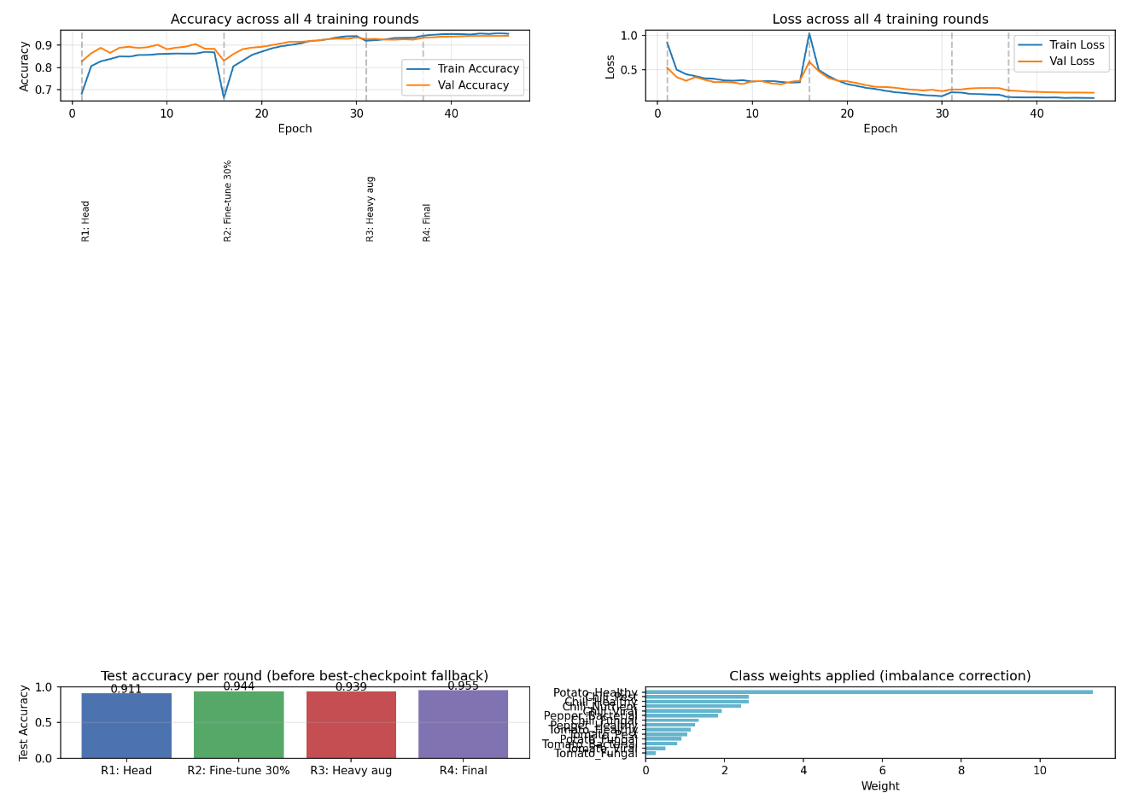
Project SproutX

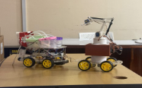
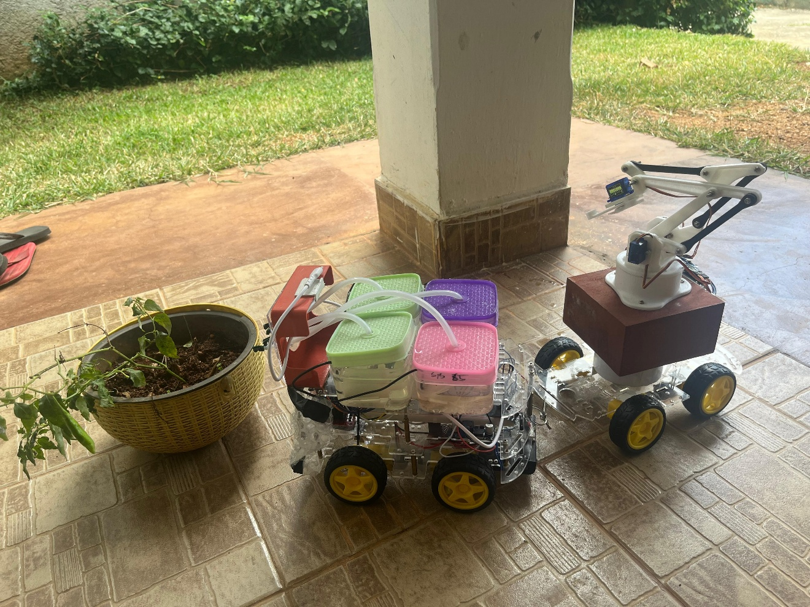
Log-Sheet

Week / Date | Activities Completed | Lecturer’s Comments | Lecturer’s Signature
Proposal Presentation  (27.05.2026) | Discussed the project idea and the Dataset used, the Crops used for disease Recognition and the Hardware implementation | Scope is Fine
1st Progress Presentation  (24.06.2026) | Brought the Hardware project with the integration of the spray system and the discussed above the dataset, Mobile Application and Website for the platform. Dataset for the AI Model was asked to train for 4 times and increase the Accuracy. | Hardware 50% completed, Consider the specific set of crops, think more about the usability and the applicability of the H/w and S/W, try to improve the accuracy with the real data set
2nd Progress Presentation  (16.07.2026) | Website Completed with the Mobile App Completed as well the Training Metrics Were shown as well. | Hardware component 80% completed. Mobile application and the dashboard completed
Final Presentation and Viva (31.07.2026)

